UNITED STATES
SECURITIES AND EXCHANGE COMMISSION
WASHINGTON, D.C. 20549

FORM 8-K

CURRENT REPORT
Pursuant to Section 13 or 15(d) of the Securities Exchange Act of 1934
Date of Report (Date of earliest event reported): August 05, 2026

Sight Sciences, Inc.
(Exact name of Registrant as Specified in Its Charter)

Delaware |  |  | 001-40587 | 80-0625749
(State or Other Jurisdiction  of Incorporation) |  |  | (Commission File Number) | (IRS Employer  Identification No.)
4040 Campbell Avenue
Suite 100
Menlo Park, California |  |  |  | 94025
(Address of Principal Executive Offices) |  |  |  | (Zip Code)

Registrant’s Telephone Number, Including Area Code: 877 266-1144

N/A
(Former Name or Former Address, if Changed Since Last Report)

Check the appropriate box below if the Form 8-K filing is intended to simultaneously satisfy the filing obligation of the registrant under any of the following provisions:
☐Written communications pursuant to Rule 425 under the Securities Act (17 CFR 230.425)
☐Soliciting material pursuant to Rule 14a-12 under the Exchange Act (17 CFR 240.14a-12)
☐Pre-commencement communications pursuant to Rule 14d-2(b) under the Exchange Act (17 CFR 240.14d-2(b))
☐Pre-commencement communications pursuant to Rule 13e-4(c) under the Exchange Act (17 CFR 240.13e-4(c))
Securities registered pursuant to Section 12(b) of the Act:
Title of each class |  | Trading  Symbol(s) |  | Name of each exchange on which registered
Common Stock, $0.001 par value per share |  | SGHT |  | The Nasdaq Global Select Market
Indicate by check mark whether the registrant is an emerging growth company as defined in Rule 405 of the Securities Act of 1933 (§ 230.405 of this chapter) or Rule 12b-2 of the Securities Exchange Act of 1934 (§ 240.12b-2 of this chapter).
Emerging growth company ☒
If an emerging growth company, indicate by check mark if the registrant has elected not to use the extended transition period for complying with any new or revised financial accounting standards provided pursuant to Section 13(a) of the Exchange Act. ☐

Item 2.02 Results of Operations and Financial Condition
On August 5, 2026, Sight Sciences, Inc. (the “Company”) issued a press release announcing its financial results for the quarter ended June 30, 2026 and raising its revenue guidance and reducing its adjusted operating expense guidance for the year ending December 31, 2026. A copy of the press release is furnished as Exhibit 99.1 to this Current Report on Form 8-K (this “Current Report”).*
Item 7.01 Regulation FD Disclosure
On August 5, 2026, the Company posted an investor presentation to its website at https://investors.sightsciences.com/. The Company expects to use the investor presentation, in whole or in part, and possibly with modifications, in connection with presentations to investors, analysts, and others. A copy of the investor presentation is furnished as Exhibit 99.2 to this Current Report.*
Item 9.01 Financial Statements and Exhibits
(d) Exhibits

Exhibit No. | Description
99.1 | Earnings Press Release dated August 5, 2026
99.2 | Sight Sciences Presentation dated August 5, 2026
104 | Cover Page Interactive Data File, formatted in Inline XBRL.

* | The information provided in Item 2.02, Item 7.01, Exhibit 99.1 and Exhibit 99.2 of this Current Report shall not be deemed “filed” for purposes of Section 18 of the Securities Exchange Act of 1934, as amended (the “Exchange Act”), or otherwise subject to the liabilities of that Section, nor shall it be deemed to be incorporated by reference into any filing of the Company under the Securities Act of 1933, as amended, or the Exchange Act, whether made before or after the date hereof, regardless of any general incorporation language in such filing, except as otherwise expressly set forth by specific reference in such filing.

SIGNATURES
Pursuant to the requirements of the Securities Exchange Act of 1934, the registrant has duly caused this report to be signed on its behalf by the undersigned thereunto duly authorized.
 |  |  | Sight Sciences, Inc.
Date: | August 5, 2026 | By: | /s/ James Rodberg
James Rodberg
Chief Financial Officer
(Principal Financial and Accounting Officer)

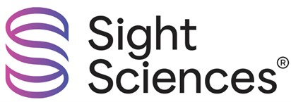

Exhibit 99.1
Sight Sciences Reports Second Quarter 2026 Financial Results

Raises Full-Year 2026 Revenue Guidance and Reduces Adjusted Operating Expense Guidance

MENLO PARK, Calif., August 5, 2026 (GLOBE NEWSWIRE) -- Sight Sciences, Inc. (Nasdaq: SGHT) (Sight Sciences or the Company), an eyecare technology company focused on developing and commercializing innovative, interventional technologies intended to transform care and improve patients’ lives, today reported financial results for the second quarter ended June 30, 2026, raised its revenue guidance and reduced its adjusted operating expense guidance, both for full year 2026.

Recent Financial and Business Highlights

•
Second quarter revenue of $23.4 million, a 20% increase compared to $19.6 million in the second quarter of 2025.

•
Interventional Glaucoma (IG) revenue of $20.7 million, an 8% increase compared to $19.2 million in the second quarter of 2025.

•
Record Interventional Dry Eye (IDE) revenue of $2.7 million, a 704% increase compared to $0.3 million in the second quarter of 2025, and a 98% increase compared to $1.4 million in the first quarter of 2026.

•
Cash and cash equivalents totaled $79.8 million as of June 30, 2026. Cash usage was $5.2 million in the second quarter 2026, a 28% improvement compared to the same period in the prior year. Cash usage included $3.8 million of non-recurring items in the quarter, including a $5.4 million litigation success fee, partially offset by $1.6 million of tariff refunds received. Excluding these one-time items, cash usage was $1.4 million, down 81% compared to the same period in the prior year.

•
Added an estimated 4.1 million patient lives in the second quarter of 2026 following publication of fee schedules from certain insurance plans that align with recently updated Medicare pricing for CPT® code 0563T, increasing total IDE patient lives with access to appropriate reimbursement from approximately 10.4 million to 14.5 million1.

•
IG coverage expanded with the addition of approximately 25 million commercial covered lives from Aetna® Inc. (Aetna), one of the largest health plans in the United States. Aetna now recognizes certain implant-free glaucoma procedures, including ab interno canaloplasty (e.g., OMNI) and adult goniotomy (e.g., SION) as medically necessary for mild-to-moderate open-angle glaucoma when specified clinical criteria are met. This coverage policy is retroactive to July 14, 2026.

•
Received U.S. Food and Drug Administration 510(k) clearance of the OMNI® Ultra Surgical System (OMNI Ultra). OMNI Ultra with TruSync Plus technology is designed to provide surgeons with improved procedural control, efficiency, and versatility, while maintaining the safety and reliability of the OMNI platform.

“We delivered a strong second quarter, with revenue growth accelerating to 20% year-over-year, and both business segments contributing meaningfully to the robust growth. Our performance reflects the growing interventional mindset across glaucoma and dry eye disease, the strength of our market-leading technologies, and the focus of our experienced commercial teams in partnering with customers to make interventional eye care the new standard of care,” said Paul Badawi, Co-Founder and CEO of Sight Sciences. “Interventional Glaucoma revenue grew 8%, marking our fourth consecutive quarter of growth, and Interventional Dry Eye revenue nearly doubled sequentially for the second consecutive quarter and reached record quarterly sales. Importantly, we achieved this growth while maintaining strong gross margins and disciplined operating expense and cash management. Based on our

year-to-date performance and business momentum, we are raising our 2026 revenue guidance, reducing our adjusted operating expense guidance and we believe we are well positioned for the second half of the year.”

Second Quarter 2026 Financial Results
Revenue for the second quarter of 2026 was $23.4 million, an increase of 20% compared to the same period in the prior year. Interventional Glaucoma revenue was $20.7 million, an increase of 8% compared to the same period in the prior year. Growth was primarily driven by increased volumes. Interventional Dry Eye revenue was $2.7 million, increasing 704% from $0.3 million in the same period in the prior year. Growth was driven primarily by increased volumes and higher average selling prices.

Gross profit for the second quarter of 2026 was $21.4 million compared to $16.6 million in the same period in the prior year. Gross margin for the second quarter of 2026 was 91%, including a $1.4 million benefit from tariff refunds received in the quarter. Excluding tariff refunds, gross margin was 86%, compared to 85% in the same period in the prior year. Interventional Glaucoma gross margin was 92%, which included a 6% benefit from tariff refunds in the quarter. Excluding tariff refunds, Interventional Glaucoma gross margin was 86%, in-line with the same period in the prior year. Interventional Dry Eye gross margin was 85%, which included a 5% benefit from tariff refunds in the quarter. Excluding tariff refunds, Interventional Dry Eye gross margin was 80%, up significantly from 38% in the same period in the prior year, primarily due to higher average selling prices.
Total operating expenses were $25.3 million in the second quarter of 2026, representing an 11% decrease compared to $28.3 million in the same period in the prior year, primarily due to lower personnel-related expenses and stock-based compensation. Research and development expenses were $2.5 million in the second quarter of 2026 compared to $4.4 million in the same period in the prior year, representing a 43% decrease. Selling, general, and administrative expenses were $22.8 million in the second quarter of 2026, compared to $23.9 million in the same period in the prior year, representing a 5% decrease. Adjusted operating expenses2,3 were $22.3 million in the second quarter of 2026, an 8% decrease compared to the same period in the prior year.

Net loss was $4.4 million, a 63% improvement from $11.9 million in the prior year period. Net loss per share was $0.08, compared to $0.23 in the second quarter of 2025.

Cash and cash equivalents totaled $79.8 million and total long-term debt was $40.0 million (excluding unamortized debt discount and debt issuance costs) as of June 30, 2026, compared to $85.0 million and $40.0 million, respectively, as of March 31, 2026. Cash used in the second quarter of 2026 totaled $5.2 million, a 28% decrease compared to $7.3 million in the second quarter of 2025.

2026 Financial Guidance
Sight Sciences raised its revenue guidance for full year 2026 to range from $88 million to $92 million, representing year-over-year growth of 14% to 19%, versus prior revenue guidance of $83 million to $89 million. This revenue guidance includes Interventional Glaucoma revenue of $79 million to $81 million, representing growth of 4% to 7%, and Interventional Dry Eye revenue of $9 million to $11 million, compared to $1.6 million in 2025.

The Company reduced its full year 2026 adjusted operating expenses2,4 guidance to range from $92 million to $94 million, representing an increase of 5% to 7% compared to 2025, versus prior adjusted operating expenses guidance of $93 million to $96 million. The increase compared to the prior year is primarily due to targeted investments in both business segments, including expanded market access efforts and additional commercial resources to scale the reimbursed dry eye market and the standalone glaucoma opportunity.

1 Published fee schedules include fee schedule amounts posted on public websites and posted by insurance plans to their provider-accessible portals. Total estimated number of patient lives is derived from publicly available information and includes Medicare Part B beneficiaries, Medicare Advantage Plan enrollees, and other insured individuals. TearCare procedure claims are payable based on individual medical necessity determinations.

2 “Adjusted operating expenses” is a financial measure not prepared in accordance with generally accepted accounting principles in the United States (“GAAP”, and is referred to as a “non-GAAP financial measure”). “Adjusted operating expenses” is calculated as operating expenses less stock-based compensation expense, depreciation and amortization, restructuring costs, and other one-time costs.
3 A reconciliation of the non-GAAP financial measure to the most directly comparable GAAP financial measure has been provided in the table titled "GAAP to Non-GAAP Reconciliation" attached to this press release.
4 Consistent with Securities and Exchange Commission (“SEC”) regulations, the Company has not provided a reconciliation of forward-looking non-GAAP financial measures to the most directly comparable GAAP financial measures in reliance on the “unreasonable efforts” exception set forth in the applicable regulations, because there is substantial uncertainty associated with predicting any future adjustments that may be made to the Company’s GAAP financial measures in calculating the non-GAAP financial measures.

Non-GAAP Financial Measures
Adjusted operating expenses, a non-GAAP financial measure, is presented in this press release to provide information that may assist investors in understanding the Company's financial and operating results. The Company believes this non-GAAP financial measure is an important performance indicator because it excludes items that are unrelated to, and may not be indicative of, the Company's core financial and operating results. This non-GAAP financial measure, as calculated, may not necessarily be comparable to similarly titled measures of other companies and may not be an appropriate measure for comparing the performance of other companies relative to the Company. This non-GAAP financial measure is not intended to represent, and should not be considered to be a more meaningful measure than, or an alternative to, measures of operating performance as determined in accordance with GAAP. To the extent the Company utilizes such non-GAAP financial measure in the future, it expects to calculate it using a consistent method from period to period. A reconciliation of adjusted operating expenses to the most directly comparable GAAP financial measure has been provided in the table titled "Non-GAAP to GAAP Reconciliation" attached to this press release.

Conference Call
Sight Sciences' management team will host a conference call today, August 5, 2026, beginning at 1:30 p.m. Pacific Time / 4:30 p.m. Eastern Time. Investors interested in listening to the conference call may do so by accessing a live and archived webcast of the event at www.sightsciences.com, on the Investors page in the News & Events section.

About Sight Sciences
Sight Sciences is an eyecare technology company focused on developing and commercializing innovative and interventional solutions intended to transform care and improve patients’ lives. Using minimally invasive or non-invasive approaches to target the underlying causes of the world’s most prevalent eye diseases, Sight Sciences seeks to create more effective treatment paradigms that enhance patient care and supplant conventional outdated approaches. The Company’s OMNI® Surgical System and OMNI® Edge Surgical System are implant-free, minimally invasive glaucoma surgery technologies indicated in the United States to reduce intraocular pressure in adult patients with primary open-angle glaucoma. The OMNI Surgical System is CE Marked for the catheterization and transluminal viscodilation of Schlemm’s canal and cutting of the trabecular meshwork to reduce intraocular pressure in adult patients with open-angle glaucoma. Glaucoma is the world’s leading cause of irreversible blindness. The SION® Surgical System is a bladeless, manually operated device used in ophthalmic surgical procedures to excise trabecular meshwork. The Company’s TearCare® System is 510(k) cleared in the United States for the application of localized heat therapy in adult patients with evaporative dry eye disease due to meibomian gland disease (MGD), enabling clearance of gland obstructions by physicians to address the leading cause of dry eye disease. Visit www.sightsciences.com for more information.
Sight Sciences, TearCare, and SmartLids are trademarks of Sight Sciences registered in the United States. OMNI, SION, and the Sight Sciences logo are trademarks of Sight Sciences registered in the United States, European Union and other territories. TruSync is a trademark of Sight Sciences.

CPT is a registered trademark of the American Medical Association. Aetna is a registered trademark of Aetna Inc.
© 2026 Sight Sciences. All rights reserved.

Forward-Looking Statements
This press release, together with other statements and information publicly disseminated by the Company, contains certain forward-looking statements within the meaning of Section 27A of the Securities Act of 1933, as amended, and Section 21E of the Securities Exchange Act of 1934, as amended. The Company intends such forward-looking statements to be covered by the safe harbor provisions for forward-looking statements contained in the Private Securities Litigation Reform Act of 1995 and includes this statement for purposes of complying with these safe harbor provisions. Any statements made in this press release or during the earnings call that are not statements of historical fact, including statements about our beliefs and expectations, are forward-looking statements and should be evaluated as such. Forward-looking statements include, but are not limited to, statements concerning the Company’s projected financial results, including revenue and adjusted operating expenses, market acceptance of our products, our ability to achieve our business strategy and objectives, our ability to make interventional eye care the new standard of care, and our ability to create long-term value for our stockholders.

These statements often include words such as "anticipate," "expect," “suggests,” “plan,” “believe,” “intend,” “estimates,” “targets,” “projects,” “should,” “could,” “would,” “may,” “will,” “forecast” and other similar expressions. We base these forward-looking statements on our current expectations, plans and assumptions we have made in light of our experience in the industry, as well as our perceptions of historical trends, current conditions, expected future developments and other factors we believe are appropriate under the circumstances at such time. Although we believe these forward-looking statements are based on reasonable assumptions at the time they are made, you should be aware that many factors could affect our business, results of operations and financial condition, including without limitation changes to reimbursement coverage or payment decisions or reimbursement rates for our products; pricing pressure or changes in market share resulting from the evolving competitive landscape; the impact of tariffs on our products and the medical device industry generally; and disruptions to or increased costs associated with our supply chain, including as a result of having a limited number of suppliers. Should our underlying assumptions prove incorrect, actual results may differ materially from those expressed in the forward-looking statements. These statements are not guarantees of future performance or results. These forward-looking statements are subject to and involve numerous risks, uncertainties and assumptions, including those discussed under the caption “Risk Factors” in our filings with the SEC, as may be updated from time to time in subsequent filings, and you should not place undue reliance on these statements. These cautionary statements are made only as of the date of this press release. We undertake no obligation to update or revise any forward-looking statements, whether as a result of new information, future events or otherwise, except as required by applicable law.

Investor contact:
Philip Taylor
Gilmartin Group
415.937.5406
Investor.Relations@Sightsciences.com
Media contact:
pr@SightSciences.com

SIGHT SCIENCES, INC.
Condensed Consolidated Balance Sheets (Unaudited)
(in thousands, except share and per share data)

 |  | June 30, |  |  |  | December 31,
 |  | 2026 |  |  |  | 2025
Assets
Current assets:
Cash and cash equivalents |  | $ | 79,753 |  |  | $ | 91,965
Accounts receivable, net of allowance for credit losses of $113 and $234 at June 30, 2026 and December 31, 2025, respectively |  |  | 11,386 |  |  |  | 9,745
Inventory, net |  |  | 5,695 |  |  |  | 7,767
Prepaid expenses and other current assets |  |  | 4,606 |  |  |  | 3,257
Total current assets |  |  | 101,440 |  |  |  | 112,734
Property and equipment, net |  |  | 1,667 |  |  |  | 1,610
Operating lease right-of-use assets |  |  | 1,185 |  |  |  | 438
Other noncurrent assets |  |  | 580 |  |  |  | 518
Total assets |  | $ | 104,872 |  |  | $ | 115,300
Liabilities and stockholders’ equity
Current liabilities:
Accounts payable |  | $ | 1,898 |  |  | $ | 1,343
Accrued compensation |  |  | 4,665 |  |  |  | 6,074
Accrued and other current liabilities |  |  | 3,805 |  |  |  | 3,610
Short-term debt, net |  |  | 10,131 |  |  |  | —
Total current liabilities |  |  | 20,499 |  |  |  | 11,027
Long-term debt, net |  |  | 30,645 |  |  |  | 40,300
Other noncurrent liabilities |  |  | 834 |  |  |  | 31
Total liabilities |  |  | 51,978 |  |  |  | 51,358
Commitments and contingencies
Stockholders’ equity:
Preferred stock, par value $0.001 per share; 10,000,000 shares authorized; no shares issued and outstanding as of June 30, 2026 and December 31, 2025 |  |  | — |  |  |  | —
Common stock, par value $0.001 per share; 200,000,000 shares authorized; 54,716,301 and 53,493,711 shares issued and outstanding as of June 30, 2026 and December 31, 2025, respectively |  |  | 55 |  |  |  | 54
Additional paid-in-capital |  |  | 454,988 |  |  |  | 448,611
Accumulated deficit |  |  | (402,149 | ) |  |  | (384,723 | )
Total stockholders’ equity |  |  | 52,894 |  |  |  | 63,942
Total liabilities and stockholders’ equity |  | $ | 104,872 |  |  | $ | 115,300

SIGHT SCIENCES, INC.
Condensed Consolidated Statements of Operations and Comprehensive Loss (Unaudited)
(in thousands, except share and per share data)

 |  | Three Months Ended  June 30, |  |  |  |  |  |  |  | Six Months Ended  June 30,
 |  | 2026 |  |  |  | 2025 |  |  |  | 2026 |  |  |  | 2025
Revenue |  | $ | 23,388 |  |  | $ | 19,564 |  |  | $ | 43,086 |  |  | $ | 37,072
Cost of goods sold |  |  | 2,014 |  |  |  | 2,977 |  |  |  | 4,734 |  |  |  | 5,391
Gross profit |  |  | 21,374 |  |  |  | 16,587 |  |  |  | 38,352 |  |  |  | 31,681
Operating expenses:
Research and development |  |  | 2,512 |  |  |  | 4,387 |  |  |  | 5,058 |  |  |  | 8,817
Selling, general and administrative |  |  | 22,750 |  |  |  | 23,867 |  |  |  | 49,595 |  |  |  | 48,390
Total operating expenses |  |  | 25,262 |  |  |  | 28,254 |  |  |  | 54,653 |  |  |  | 57,207
Loss from operations |  |  | (3,888 | ) |  |  | (11,667 | ) |  |  | (16,301 | ) |  |  | (25,526 | )
Investment income |  |  | 678 |  |  |  | 1,026 |  |  |  | 1,419 |  |  |  | 2,174
Interest expense |  |  | (1,290 | ) |  |  | (1,284 | ) |  |  | (2,557 | ) |  |  | (2,547 | )
Other income (expense), net |  |  | 82 |  |  |  | 24 |  |  |  | 53 |  |  |  | (115 | )
Loss before income taxes |  |  | (4,418 | ) |  |  | (11,901 | ) |  |  | (17,386 | ) |  |  | (26,014 | )
Provision for income taxes |  |  | 28 |  |  |  | 40 |  |  |  | 40 |  |  |  | 81
Net loss and comprehensive loss |  | $ | (4,446 | ) |  | $ | (11,941 | ) |  | $ | (17,426 | ) |  | $ | (26,095 | )
Net loss per share attributable to common stockholders, basic and diluted |  | $ | (0.08 | ) |  | $ | (0.23 | ) |  | $ | (0.32 | ) |  | $ | (0.51 | )
Weighted-average shares used in computing net loss per share attributable to common stockholders, basic and diluted |  |  | 54,505,792 |  |  |  | 51,821,773 |  |  |  | 54,225,993 |  |  |  | 51,557,686

SIGHT SCIENCES, INC.
Gross Margin Disaggregation (Unaudited)
(in thousands)

 |  | Three Months Ended June 30, |  |  |  |  |  |  |  | Six Months Ended June 30,
 |  | 2026 |  |  |  | 2025 |  |  |  | 2026 |  |  |  | 2025
Revenue
Interventional Glaucoma |  | $ | 20,713 |  |  | $ | 19,231 |  |  | $ | 39,058 |  |  | $ | 36,345
Interventional Dry Eye |  |  | 2,675 |  |  |  | 333 |  |  |  | 4,028 |  |  |  | 727
Total revenue |  |  | 23,388 |  |  |  | 19,564 |  |  |  | 43,086 |  |  |  | 37,072
Cost of goods sold
Interventional Glaucoma |  |  | 1,604 |  |  |  | 2,772 |  |  |  | 3,947 |  |  |  | 5,070
Interventional Dry Eye |  |  | 410 |  |  |  | 205 |  |  |  | 787 |  |  |  | 321
Total cost of goods sold |  |  | 2,014 |  |  |  | 2,977 |  |  |  | 4,734 |  |  |  | 5,391
Gross profit
Interventional Glaucoma |  |  | 19,109 |  |  |  | 16,459 |  |  |  | 35,111 |  |  |  | 31,275
Interventional Dry Eye |  |  | 2,265 |  |  |  | 128 |  |  |  | 3,241 |  |  |  | 406
Total gross profit |  |  | 21,374 |  |  |  | 16,587 |  |  |  | 38,352 |  |  |  | 31,681
Gross margin
Interventional Glaucoma |  |  | 92.3 | % |  |  | 85.6 | % |  |  | 89.9 | % |  |  | 86.1 | %
Interventional Dry Eye |  |  | 84.7 | % |  |  | 38.4 | % |  |  | 80.5 | % |  |  | 55.8 | %
Total gross margin |  |  | 91.4 | % |  |  | 84.8 | % |  |  | 89.0 | % |  |  | 85.5 | %

SIGHT SCIENCES, INC.
GAAP to Non-GAAP Reconciliation (Unaudited)
(in thousands)

 |  | Three Months Ended  June 30, |  |  |  |  |  |  |  | Six Months Ended  June 30,
 |  | 2026 |  |  |  | 2025 |  |  |  | 2026 |  |  |  | 2025
Operating Expenses:
Total Operating Expenses |  | $ | 25,262 |  |  | $ | 28,254 |  |  | $ | 54,653 |  |  | $ | 57,207
Less: Stock-based Compensation |  |  | (2,841 | ) |  |  | (3,735 | ) |  |  | (5,573 | ) |  |  | (7,863 | )
Less: Depreciation and Amortization |  |  | (94 | ) |  |  | (125 | ) |  |  | (197 | ) |  |  | (274 | )
Less: Restructuring Costs |  |  | — |  |  |  | — |  |  |  | — |  |  |  | —
Less: Litigation Success Fee |  |  | — |  |  |  | — |  |  |  | (5,393 | ) |  |  | —
Adjusted Operating Expenses(5) |  |  | 22,327 |  |  |  | 24,394 |  |  |  | 43,490 |  |  |  | 49,070

5 Please see section titled "Non-GAAP Financial Measures" for additional information.

SIGHT SCIENCES, INC.
Supplemental Financial Measures (Unaudited)

Three Months Ended
June 30,
 |  | 2026 |  |  |  | 2025
Interventional Glaucoma active customers (6) |  |  | 1,214 |  |  |  | 1,174
Interventional Dry Eye lid treatment units sold (7) |  |  | 3,091 |  |  |  | 1,142
Interventional Dry Eye active customers (8) |  |  | 176 |  |  |  | 39

6 “Interventional Glaucoma active customers” means the number of customers who ordered the OMNI Surgical System or the SION Surgical Instrument during the three months ended June 30, 2026 and 2025.
7 “Interventional Dry Eye lid treatment units sold” means the quantity of TearCare SmartLids® sold during the three months ended June 30, 2026 and 2025.
8 “Interventional Dry Eye active customers” means the number of customers who ordered lid treatment units during the three months ended June 30, 2026 and 2025.


Investor Presentation August 2026

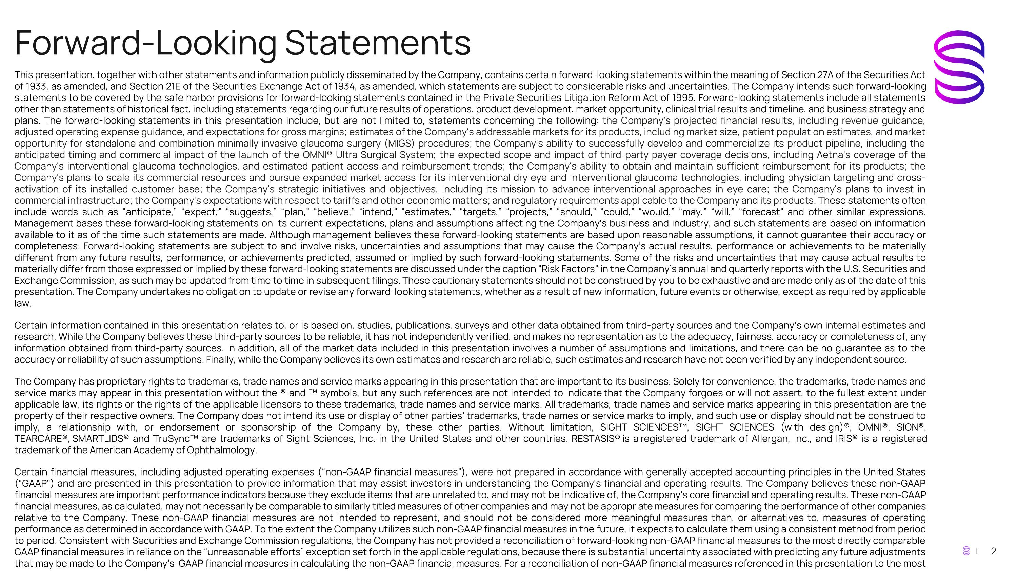
Forward-Looking Statements This presentation, together with other statements and information publicly disseminated by the Company, contains certain forward-looking statements within the meaning of Section 27A of the Securities Act of 1933, as amended, and Section 21E of the Securities Exchange Act of 1934, as amended, which statements are subject to considerable risks and uncertainties. The Company intends such forward-looking statements to be covered by the safe harbor provisions for forward-looking statements contained in the Private Securities Litigation Reform Act of 1995. Forward-looking statements include all statements other than statements of historical fact, including statements regarding our future results of operations, product development, market opportunity, clinical trial results and timeline, and business strategy and plans. The forward-looking statements in this presentation include, but are not limited to, statements concerning the following: the Company's projected financial results, including revenue guidance, adjusted operating expense guidance, and expectations for gross margins; estimates of the Company's addressable markets for its products, including market size, patient population estimates, and market opportunity for standalone and combination minimally invasive glaucoma surgery (MIGS) procedures; the Company's ability to successfully develop and commercialize its product pipeline, including the anticipated timing and commercial impact of the launch of the OMNI® Ultra Surgical System; the expected scope and impact of third-party payer coverage decisions, including Aetna's coverage of the Company's interventional glaucoma technologies, and estimated patient access and reimbursement trends; the Company's ability to obtain and maintain sufficient reimbursement for its products; the Company's plans to scale its commercial resources and pursue expanded market access for its interventional dry eye and interventional glaucoma technologies, including physician targeting and cross-activation of its installed customer base; the Company's strategic initiatives and objectives, including its mission to advance interventional approaches in eye care; the Company's plans to invest in commercial infrastructure; the Company's expectations with respect to tariffs and other economic matters; and regulatory requirements applicable to the Company and its products. These statements often include words such as “anticipate,” “expect,” “suggests,” “plan,” “believe,” “intend,” “estimates,” “targets,” “projects,” “should,” “could,” “would,” “may,” “will,” “forecast” and other similar expressions. Management bases these forward-looking statements on its current expectations, plans and assumptions affecting the Company’s business and industry, and such statements are based on information available to it as of the time such statements are made. Although management believes these forward-looking statements are based upon reasonable assumptions, it cannot guarantee their accuracy or completeness. Forward-looking statements are subject to and involve risks, uncertainties and assumptions that may cause the Company’s actual results, performance or achievements to be materially different from any future results, performance, or achievements predicted, assumed or implied by such forward-looking statements. Some of the risks and uncertainties that may cause actual results to materially differ from those expressed or implied by these forward-looking statements are discussed under the caption “Risk Factors” in the Company’s annual and quarterly reports with the U.S. Securities and Exchange Commission, as such may be updated from time to time in subsequent filings. These cautionary statements should not be construed by you to be exhaustive and are made only as of the date of this presentation. The Company undertakes no obligation to update or revise any forward-looking statements, whether as a result of new information, future events or otherwise, except as required by applicable law. Certain information contained in this presentation relates to, or is based on, studies, publications, surveys and other data obtained from third-party sources and the Company’s own internal estimates and research. While the Company believes these third-party sources to be reliable, it has not independently verified, and makes no representation as to the adequacy, fairness, accuracy or completeness of, any information obtained from third-party sources. In addition, all of the market data included in this presentation involves a number of assumptions and limitations, and there can be no guarantee as to the accuracy or reliability of such assumptions. Finally, while the Company believes its own estimates and research are reliable, such estimates and research have not been verified by any independent source. The Company has proprietary rights to trademarks, trade names and service marks appearing in this presentation that are important to its business. Solely for convenience, the trademarks, trade names and service marks may appear in this presentation without the ® and  symbols, but any such references are not intended to indicate that the Company forgoes or will not assert, to the fullest extent under applicable law, its rights or the rights of the applicable licensors to these trademarks, trade names and service marks. All trademarks, trade names and service marks appearing in this presentation are the property of their respective owners. The Company does not intend its use or display of other parties’ trademarks, trade names or service marks to imply, and such use or display should not be construed to imply, a relationship with, or endorsement or sponsorship of the Company by, these other parties. Without limitation, SIGHT SCIENCES, SIGHT SCIENCES (with design)®, OMNI®, SION®, TEARCARE®, SMARTLIDS® and TruSync are trademarks of Sight Sciences, Inc. in the United States and other countries. RESTASIS® is a registered trademark of Allergan, Inc., and IRIS® is a registered trademark of the American Academy of Ophthalmology. Certain financial measures, including adjusted operating expenses (“non-GAAP financial measures”), were not prepared in accordance with generally accepted accounting principles in the United States (“GAAP") and are presented in this presentation to provide information that may assist investors in understanding the Company's financial and operating results. The Company believes these non-GAAP financial measures are important performance indicators because they exclude items that are unrelated to, and may not be indicative of, the Company's core financial and operating results. These non-GAAP financial measures, as calculated, may not necessarily be comparable to similarly titled measures of other companies and may not be appropriate measures for comparing the performance of other companies relative to the Company. These non-GAAP financial measures are not intended to represent, and should not be considered more meaningful measures than, or alternatives to, measures of operating performance as determined in accordance with GAAP. To the extent the Company utilizes such non-GAAP financial measures in the future, it expects to calculate them using a consistent method from period to period. Consistent with Securities and Exchange Commission regulations, the Company has not provided a reconciliation of forward-looking non-GAAP financial measures to the most directly comparable GAAP financial measures in reliance on the “unreasonable efforts” exception set forth in the applicable regulations, because there is substantial uncertainty associated with predicting any future adjustments that may be made to the Company’s GAAP financial measures in calculating the non-GAAP financial measures. For a reconciliation of non-GAAP financial measures referenced in this presentation to the most directly comparable GAAP measures, please refer to the Company's earnings release issued on August 5, 2026.

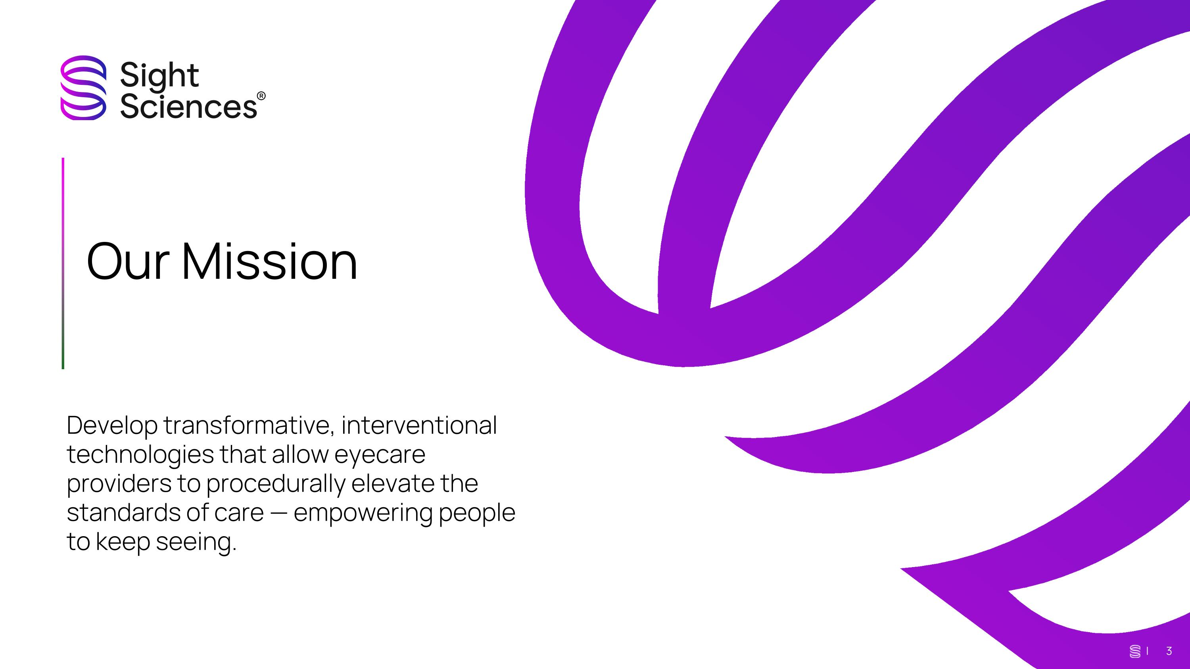
[[ Our Mission Develop transformative, interventional technologies that allow eyecare providers to procedurally elevate the standards of care — empowering people to keep seeing. | 3

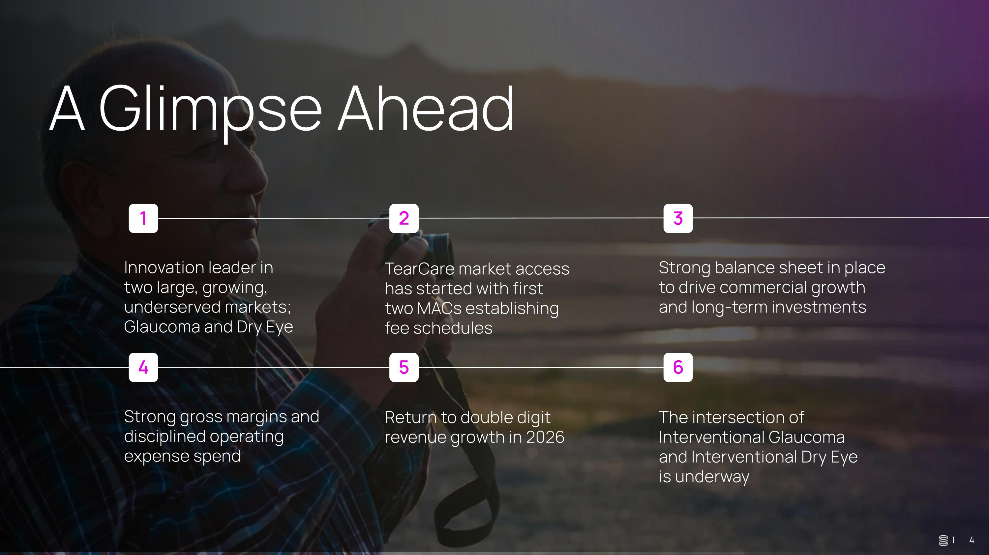
A Glimpse Ahead Innovation leader in ?two large, growing, underserved markets; Glaucoma and Dry Eye 1 TearCare market access has started with first two MACs establishing fee schedules 2 Strong balance sheet in place to drive commercial growth and long-term investments 3 Strong gross margins and disciplined operating expense spend 4 Return to double digit revenue growth in 2026 5 | 4 The intersection of Interventional Glaucoma and Interventional Dry Eye is underway 6

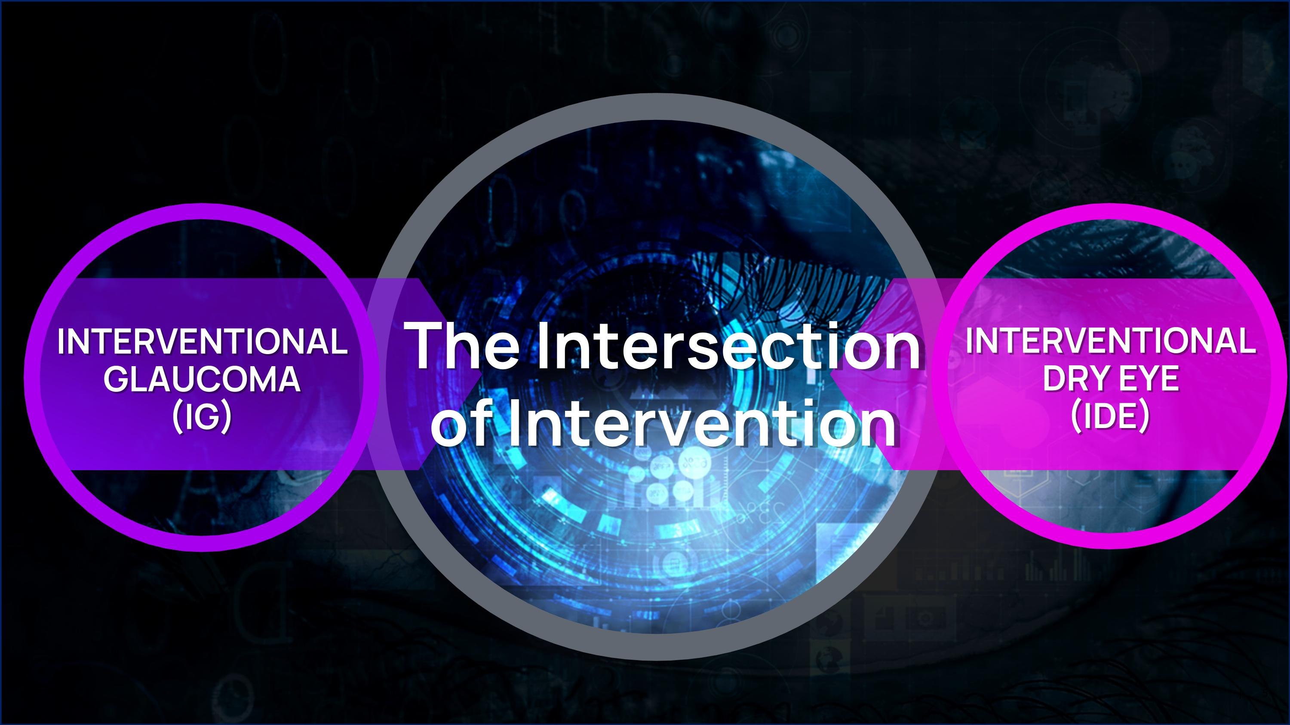
INTERVENTIONAL GLAUCOMA (IG) INTERVENTIONAL DRY EYE (IDE) The Intersection ?of Intervention

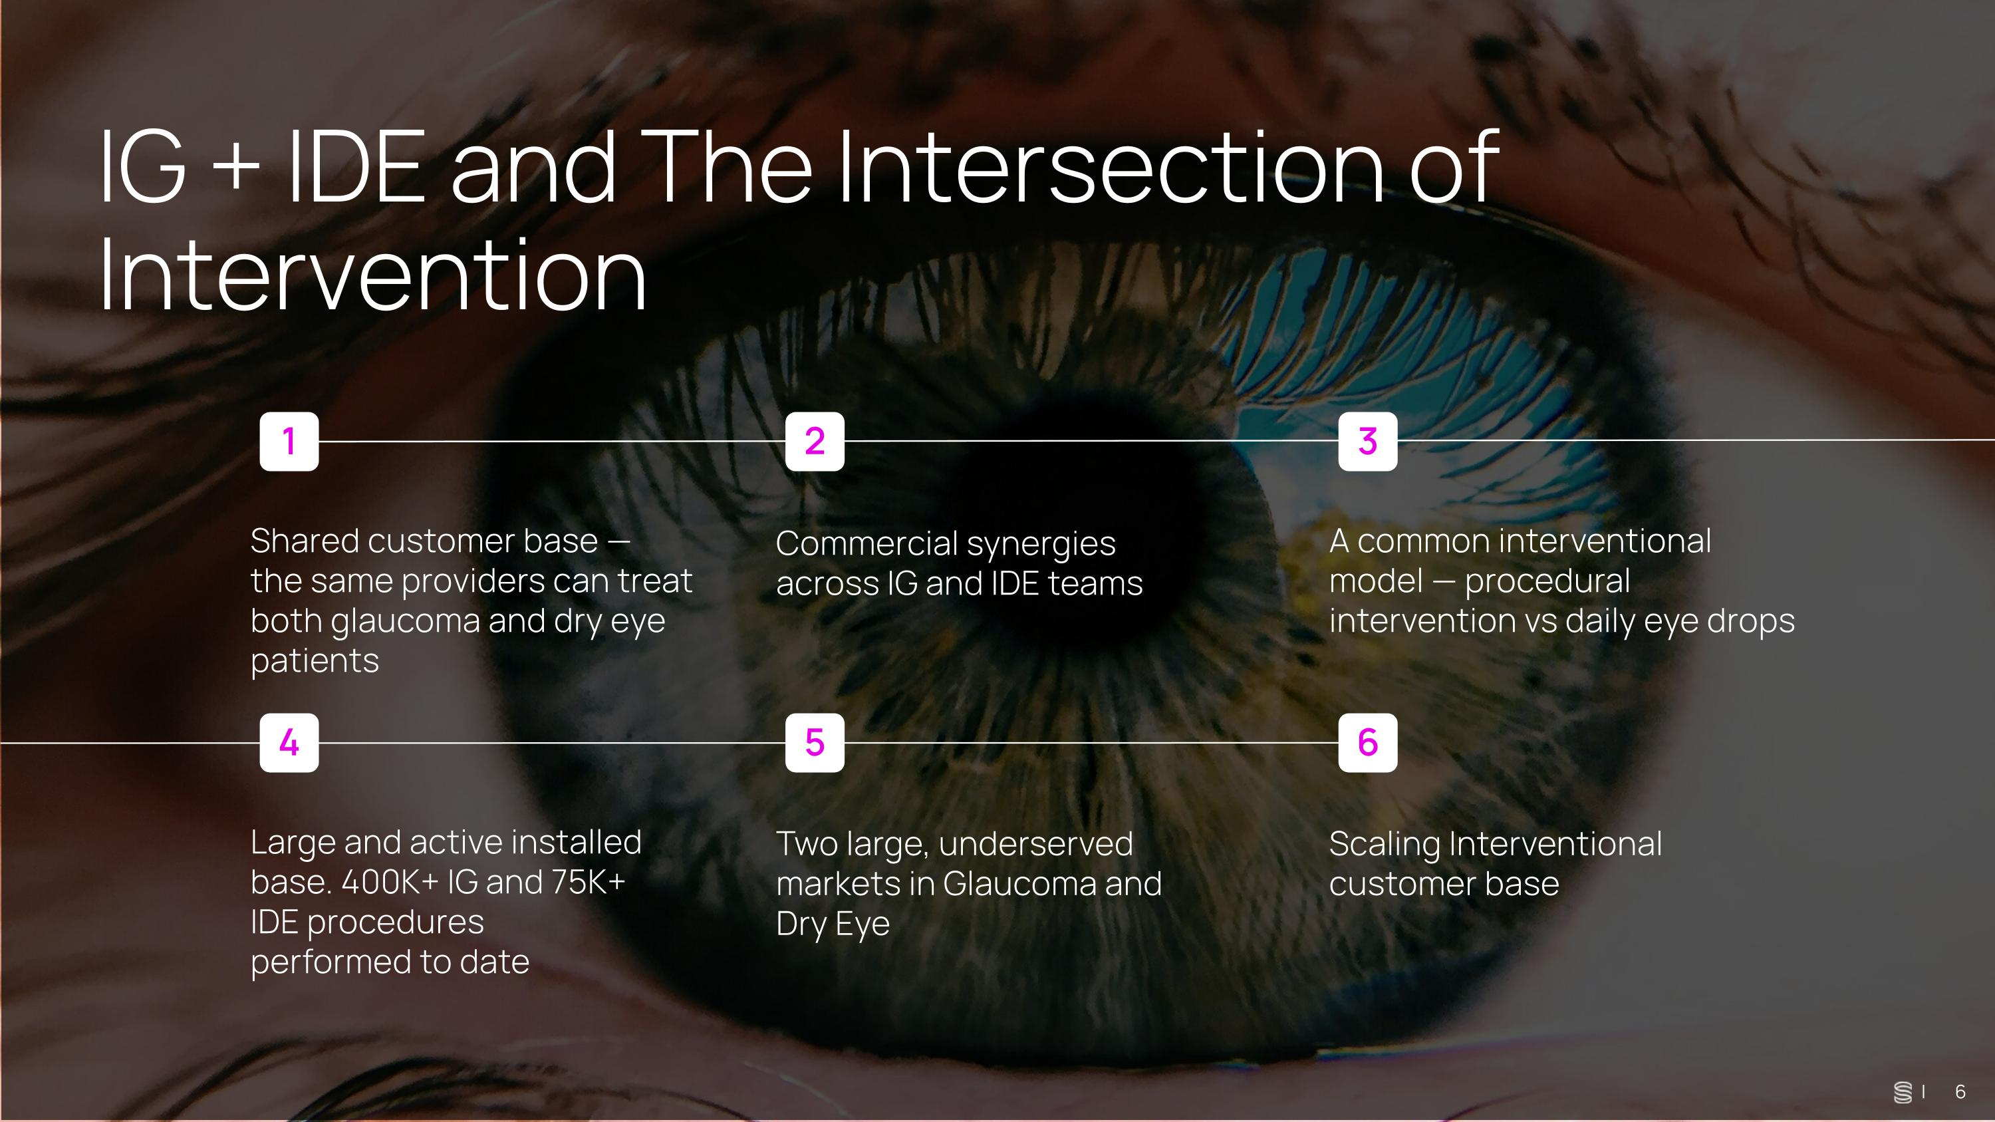
IG + IDE and The Intersection of Intervention Shared customer base — ?the same providers can treat both glaucoma and dry eye patients 1 Commercial synergies across IG and IDE teams 2 A common interventional model — procedural intervention vs daily eye drops 3 Large and active installed base. 400K+ IG and 75K+ IDE procedures performed to date 4 Two large, underserved markets in Glaucoma and Dry Eye 5 | 6 Scaling Interventional customer base 6

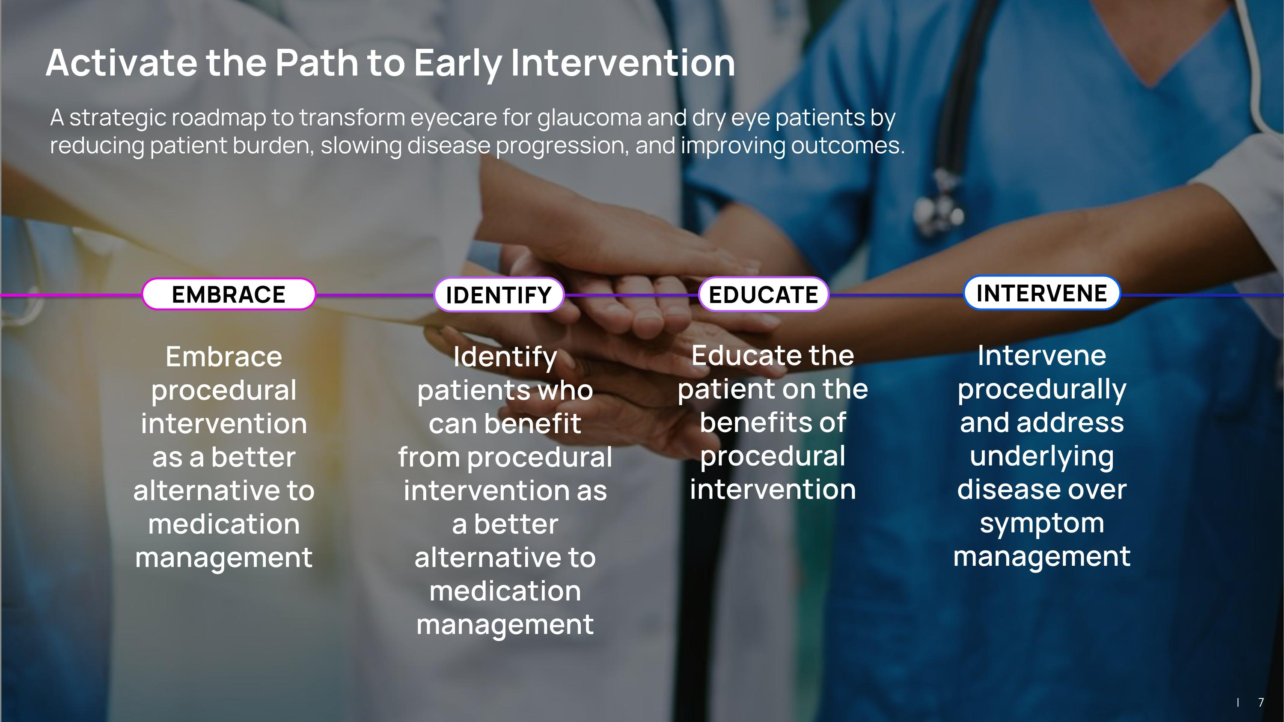
A strategic roadmap to transform eyecare for glaucoma and dry eye patients by reducing patient burden, slowing disease progression, and improving outcomes. Embrace procedural intervention as a better alternative to medication management Intervene procedurally and address underlying disease over symptom management EMBRACE INTERVENE Identify patients who can benefit from procedural intervention as a better alternative to medication management IDENTIFY Activate the Path to Early Intervention EDUCATE Educate the patient on the benefits of procedural intervention | 7

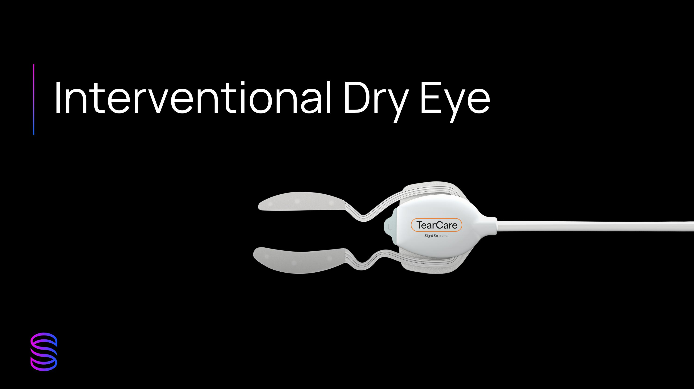
Interventional Dry Eye

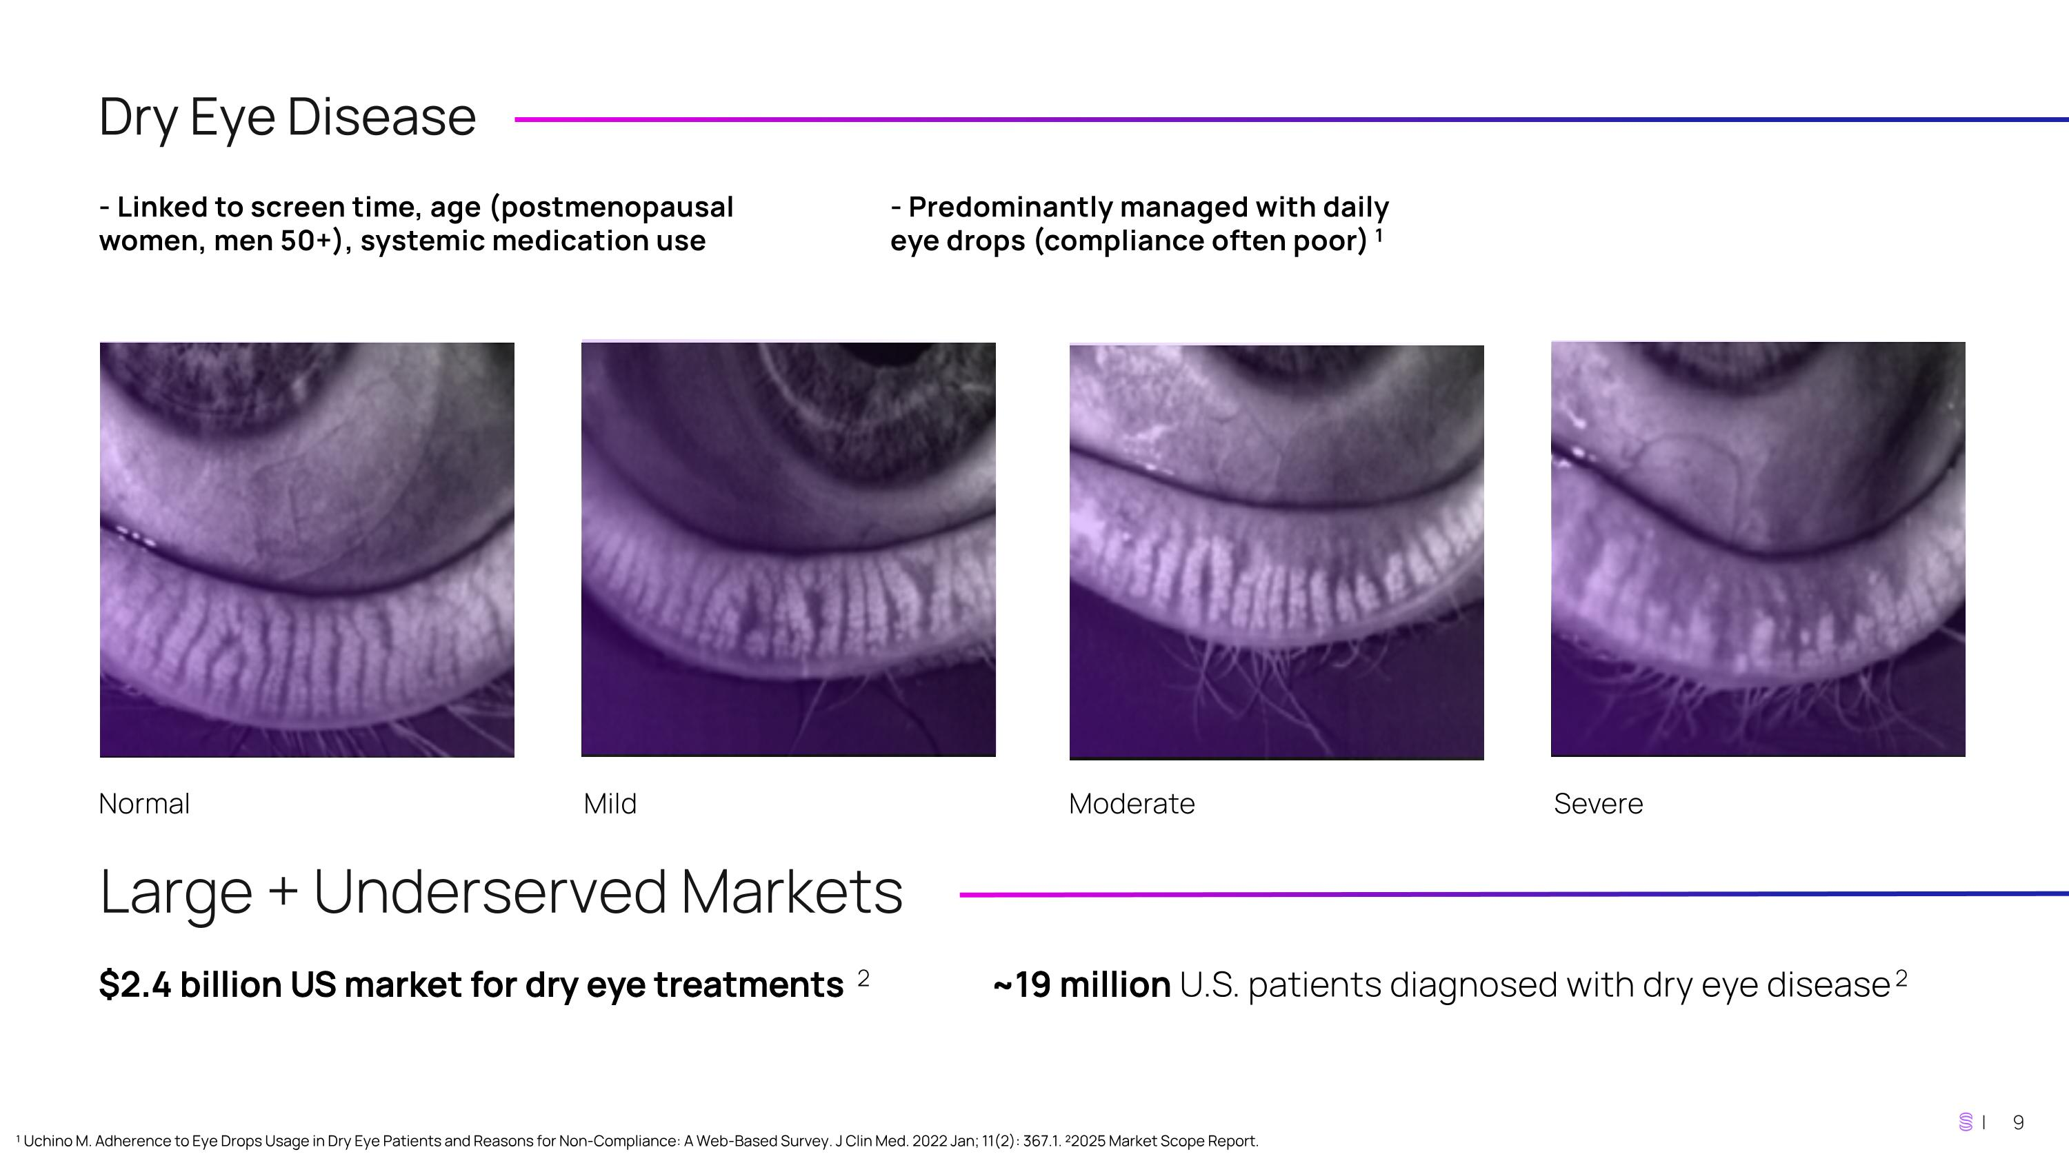
Dry Eye Disease - Linked to screen time, age (postmenopausal women, men 50+), systemic medication use - Predominantly managed with daily eye drops (compliance often poor)1 Normal Mild Moderate Severe Large + Underserved Markets $2.4 billion US market for dry eye treatments 2 ~19 million U.S. patients diagnosed with dry eye disease2 ¹ Uchino M. Adherence to Eye Drops Usage in Dry Eye Patients and Reasons for Non-Compliance: A Web-Based Survey. J Clin Med. 2022 Jan; 11(2): 367.1. ²2025 Market Scope Report.

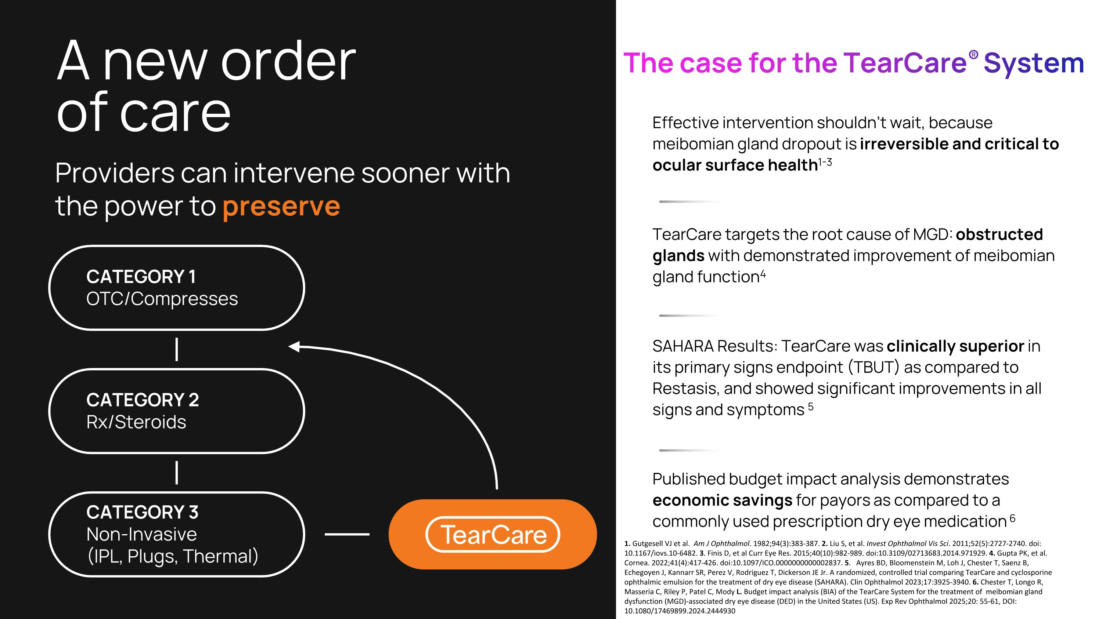
A new order ?of care Effective intervention shouldn’t wait, because meibomian gland dropout is irreversible and critical to ocular surface health1-3 TearCare targets the root cause of MGD: obstructed glands with demonstrated improvement of meibomian gland function4 SAHARA Results: TearCare was clinically superior in its primary signs endpoint (TBUT) as compared to Restasis, and showed significant improvements in all signs and symptoms 5 Published budget impact analysis demonstrates economic savings for payors as compared to a commonly used prescription dry eye medication 6 Providers can intervene sooner with the power to preserve The case for the TearCare® System CATEGORY 1 OTC/Compresses CATEGORY 2 Rx/Steroids CATEGORY 3 Non-Invasive ?(IPL, Plugs, Thermal) 1. Gutgesell VJ et al. Am J Ophthalmol. 1982;94(3):383-387. 2. Liu S, et al. Invest Ophthalmol Vis Sci. 2011;52(5):2727-2740. doi: 10.1167/iovs.10-6482. 3. Finis D, et al Curr Eye Res. 2015;40(10):982-989. doi:10.3109/02713683.2014.971929. 4. Gupta PK, et al. Cornea. 2022;41(4):417-426. doi:10.1097/ICO.0000000000002837. 5. Ayres BD, Bloomenstein M, Loh J, Chester T, Saenz B, Echegoyen J, Kannarr SR, Perez V, Rodriguez T, Dickerson JE Jr. A randomized, controlled trial comparing TearCare and cyclosporine ophthalmic emulsion for the treatment of dry eye disease (SAHARA). Clin Ophthalmol 2023;17:3925-3940. 6. Chester T, Longo R, Masseria C, Riley P, Patel C, Mody L. Budget impact analysis (BIA) of the TearCare System for the treatment of meibomian gland dysfunction (MGD)-associated dry eye disease (DED) in the United States (US). Exp Rev Ophthalmol 2025;20: 55-61, DOI: 10.1080/17469899.2024.2444930

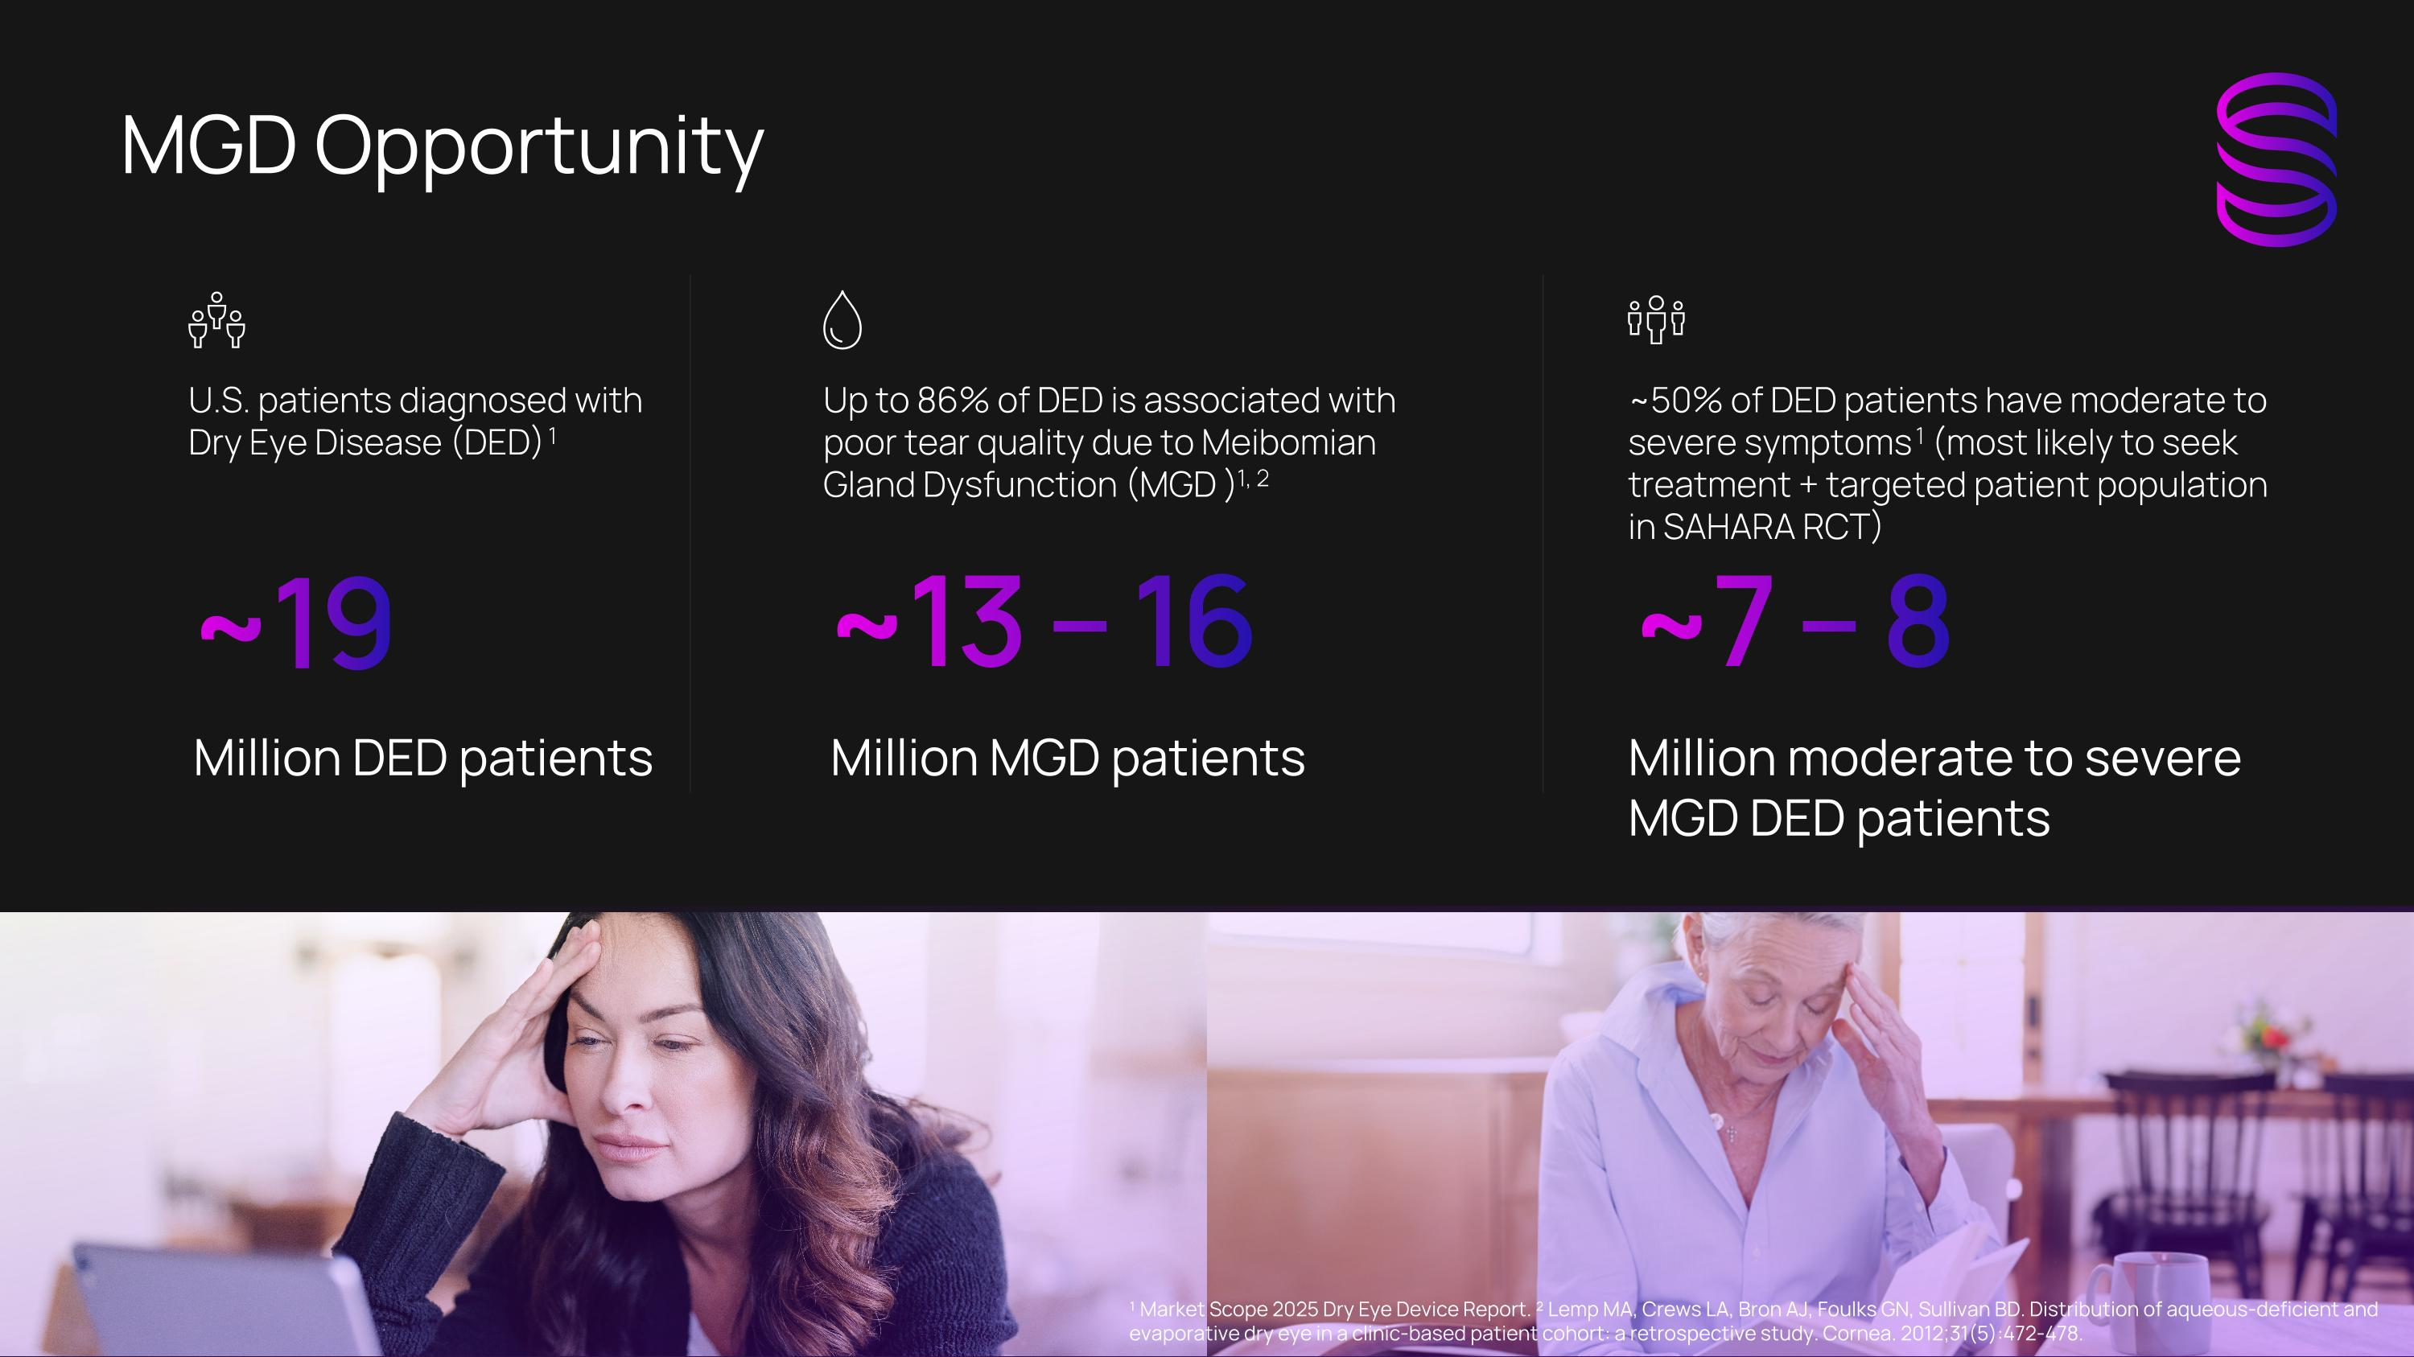
MGD Opportunity U.S. patients diagnosed with Dry Eye Disease (DED) 1 Million DED patients ~19 Up to 86% of DED is associated with poor tear quality due to Meibomian Gland Dysfunction (MGD )1, 2 Million MGD patients ~13 – 16 ~50% of DED patients have moderate to severe symptoms 1 (most likely to seek treatment + targeted patient population in SAHARA RCT) Million moderate to severe MGD DED patients ~7 – 8 ¹ Market Scope 2025 Dry Eye Device Report. ² Lemp MA, Crews LA, Bron AJ, Foulks GN, Sullivan BD. Distribution of aqueous-deficient and evaporative dry eye in a clinic-based patient cohort: a retrospective study. Cornea. 2012;31(5):472-478.

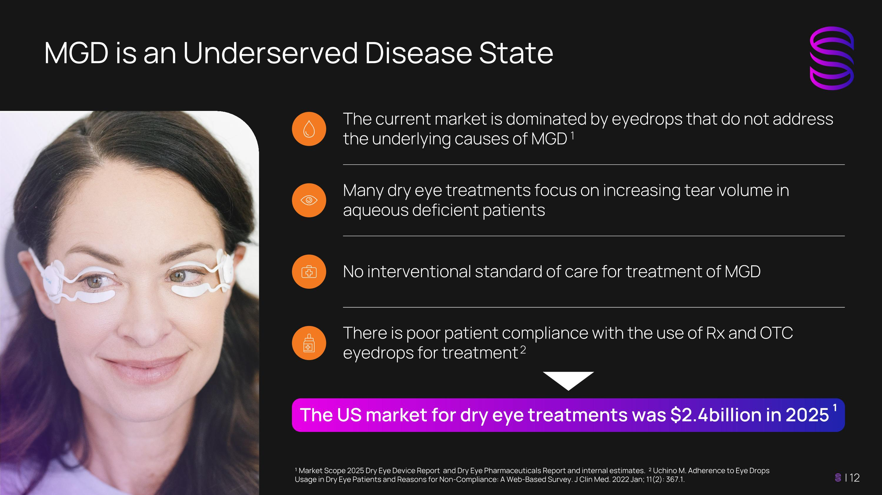
MGD is an Underserved Disease State The current market is dominated by eyedrops that do not address the underlying causes of MGD 1 Many dry eye treatments focus on increasing tear volume in aqueous deficient patients No interventional standard of care for treatment of MGD There is poor patient compliance with the use of Rx and OTC eyedrops for treatment 2 The US market for dry eye treatments was $2.4 billion in 2025 1 ¹ Market Scope 2025 Dry Eye Device Report and Dry Eye Pharmaceuticals Report and internal estimates. ² Uchino M. Adherence to Eye Drops Usage in Dry Eye Patients and Reasons for Non-Compliance: A Web-Based Survey. J Clin Med. 2022 Jan; 11(2): 367.1.

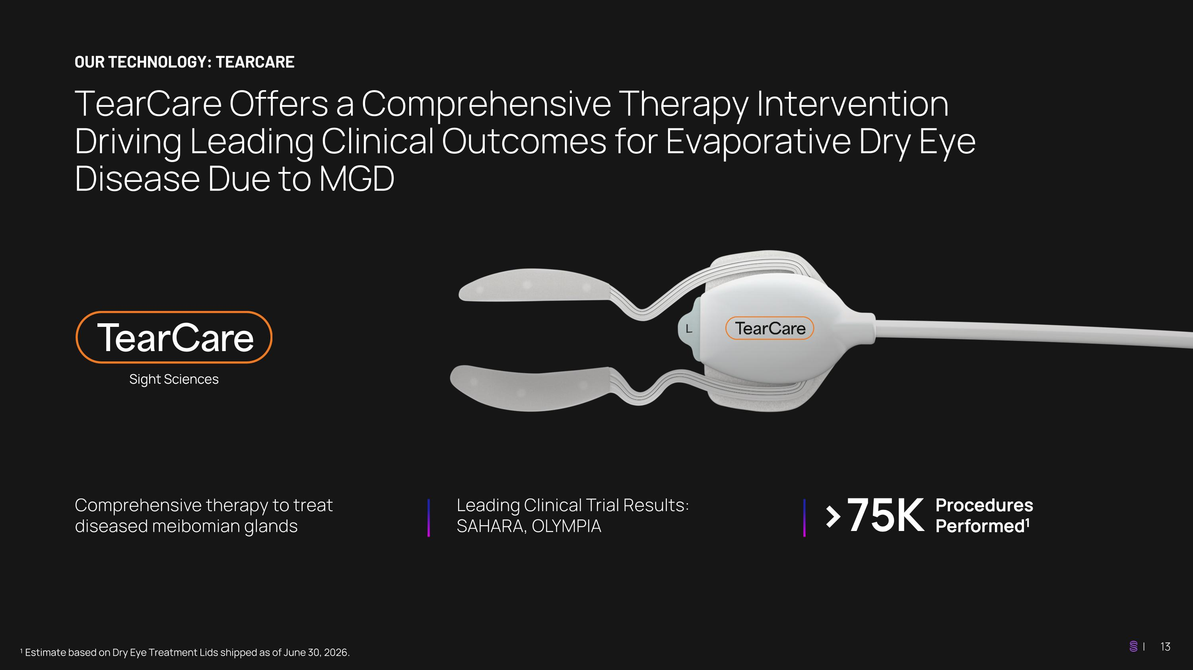
TearCare Offers a Comprehensive Therapy Intervention Driving Leading Clinical Outcomes for Evaporative Dry Eye Disease Due to MGD OUR TECHNOLOGY: TEARCARE ¹ Estimate based on Dry Eye Treatment Lids shipped as of June 30, 2026. Comprehensive therapy to treat diseased meibomian glands Leading Clinical Trial Results: SAHARA, OLYMPIA >75K Procedures Performed1

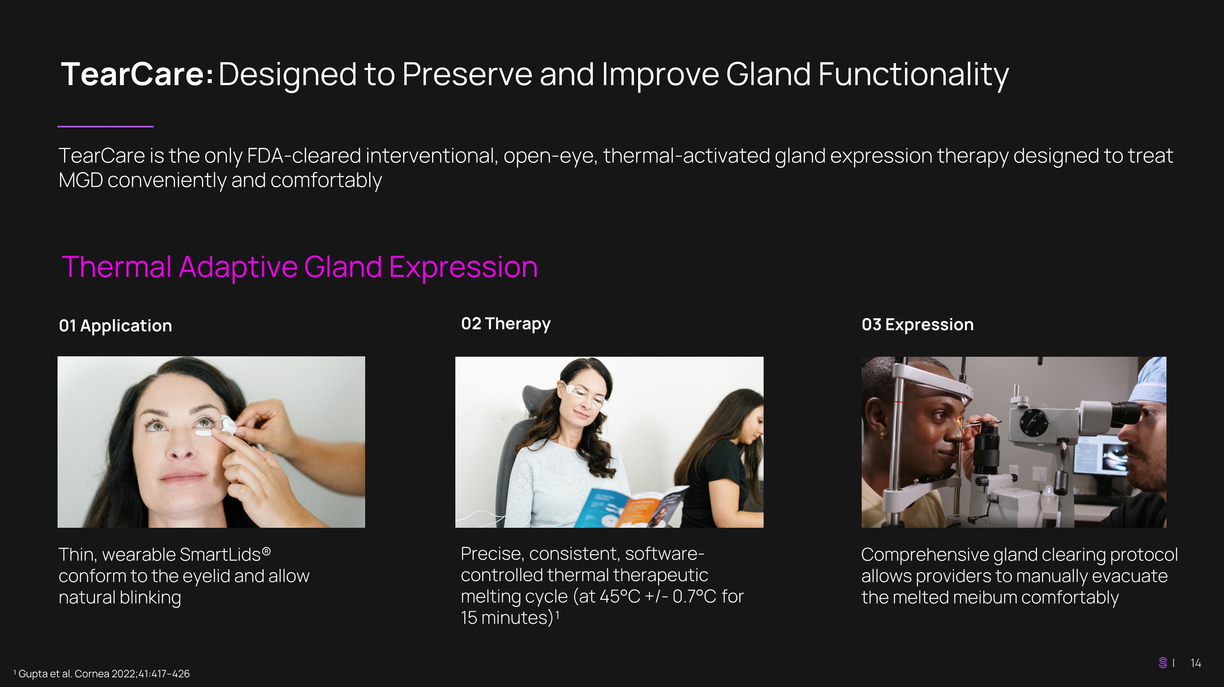
TearCare: Designed to Preserve and Improve Gland Functionality TearCare is the only FDA-cleared interventional, open-eye, thermal-activated gland expression therapy designed to treat MGD conveniently and comfortably ¹ Gupta et al. Cornea 2022;41:417–426 Thin, wearable SmartLids® conform to the eyelid and allow natural blinking Precise, consistent, software- controlled thermal therapeutic melting cycle (at 45°C +/- 0.7°C for 15 minutes)¹ Comprehensive gland clearing protocol allows providers to manually evacuate the melted meibum comfortably 01 Application 02 Therapy 03 Expression Thermal Adaptive Gland Expression

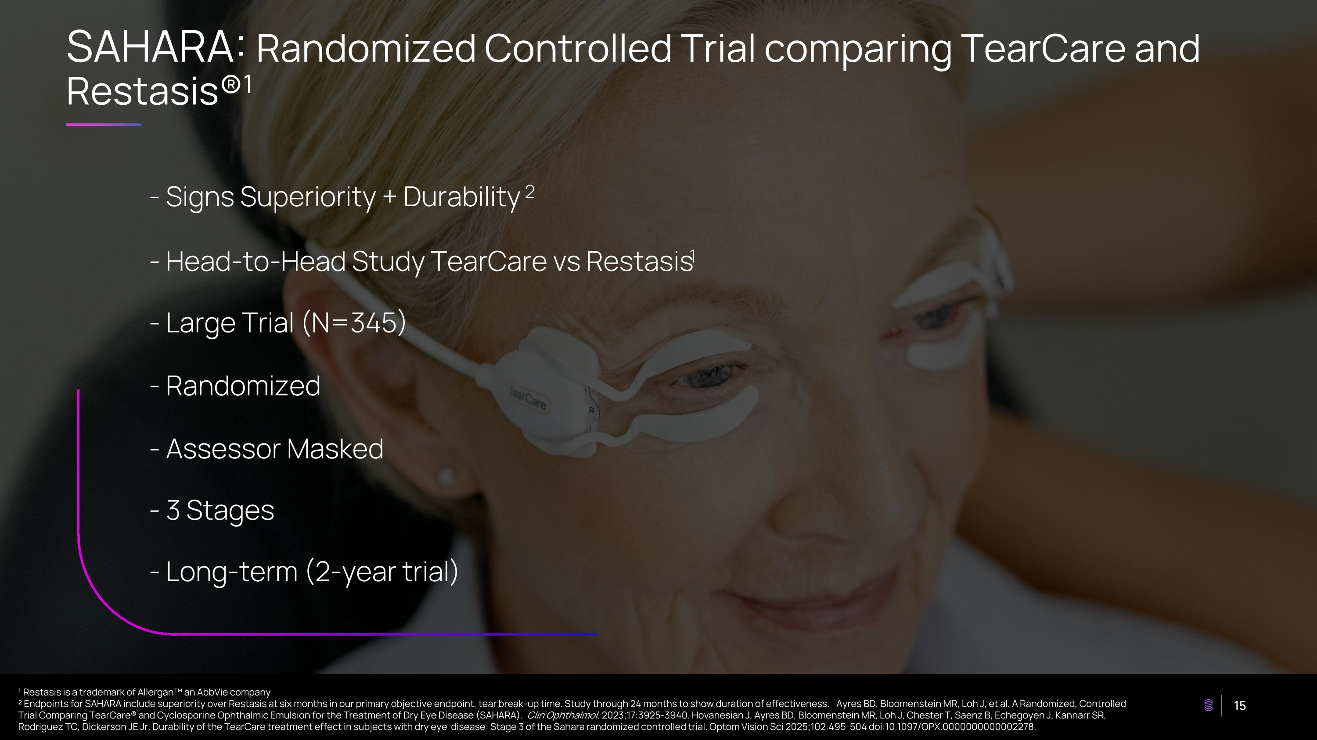
SAHARA: Randomized Controlled Trial comparing TearCare and Restasis®1 - Signs Superiority + Durability 2 - Head-to-Head Study TearCare vs Restasis1 - Large Trial (N=345) - Randomized - Assessor Masked - 3 Stages - Long-term (2-year trial) ¹ Restasis is a trademark of Allergan an AbbVie company ² Endpoints for SAHARA include superiority over Restasis at six months in our primary objective endpoint, tear break-up time. Study through 24 months to show duration of effectiveness. Ayres BD, Bloomenstein MR, Loh J, et al. A Randomized, Controlled Trial Comparing TearCare® and Cyclosporine Ophthalmic Emulsion for the Treatment of Dry Eye Disease (SAHARA). Clin Ophthalmol. 2023;17:3925-3940. Hovanesian J, Ayres BD, Bloomenstein MR, Loh J, Chester T, Saenz B, Echegoyen J, Kannarr SR, Rodriguez TC, Dickerson JE Jr. Durability of the TearCare treatment effect in subjects with dry eye disease: Stage 3 of the Sahara randomized controlled trial. Optom Vision Sci 2025;102:495-504 doi:10.1097/OPX.0000000000002278.

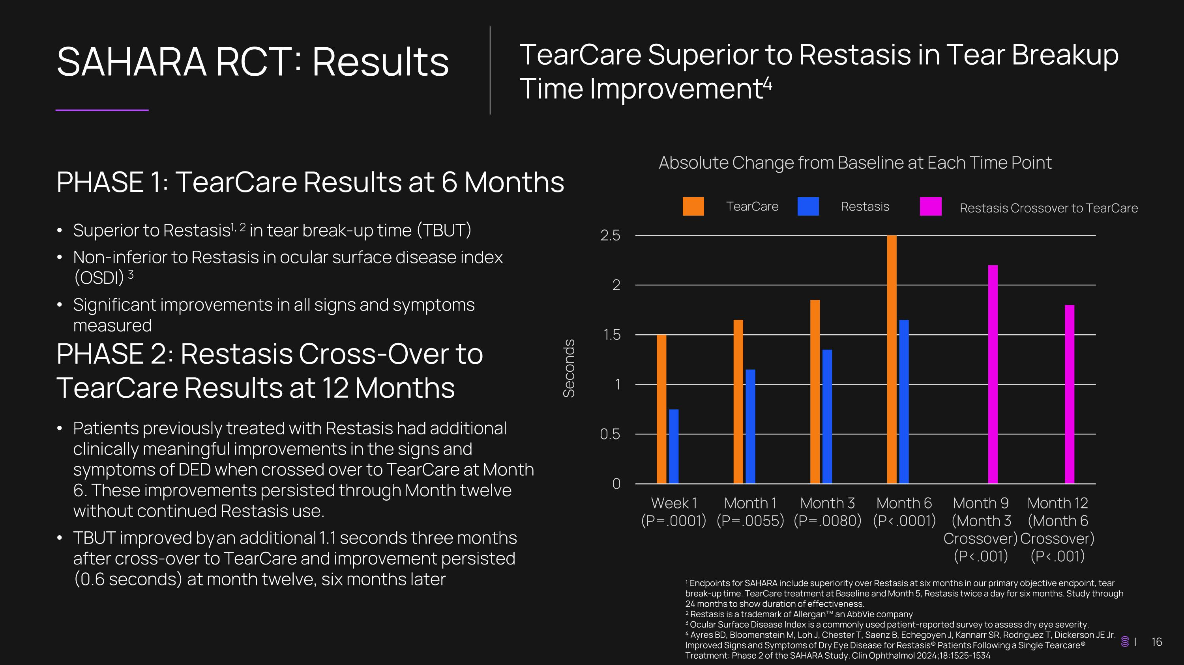
SAHARA RCT: Results ¹ Endpoints for SAHARA include superiority over Restasis at six months in our primary objective endpoint, tear break-up time. TearCare treatment at Baseline and Month 5, Restasis twice a day for six months. Study through 24 months to show duration of effectiveness. ² Restasis is a trademark of Allergan an AbbVie company 3 Ocular Surface Disease Index is a commonly used patient-reported survey to assess dry eye severity. 4 Ayres BD, Bloomenstein M, Loh J, Chester T, Saenz B, Echegoyen J, Kannarr SR, Rodriguez T, Dickerson JE Jr. Improved Signs and Symptoms of Dry Eye Disease for Restasis® Patients Following a Single Tearcare® Treatment: Phase 2 of the SAHARA Study. Clin Ophthalmol 2024;18:1525-1534 TearCare Superior to Restasis in Tear Breakup Time Improvement4 PHASE 1: TearCare Results at 6 Months Superior to Restasis1, 2 in tear break-up time (TBUT) Non-inferior to Restasis in ocular surface disease index (OSDI) 3 Significant improvements in all signs and symptoms measured Seconds Absolute Change from Baseline at Each Time Point TearCare Restasis Patients previously treated with Restasis had additional clinically meaningful improvements in the signs and symptoms of DED when crossed over to TearCare at Month 6. These improvements persisted through Month twelve without continued Restasis use. TBUT improved by an additional 1.1 seconds three months after cross-over to TearCare and improvement persisted (0.6 seconds) at month twelve, six months later PHASE 2: Restasis Cross-Over to TearCare Results at 12 Months Restasis Crossover to TearCare

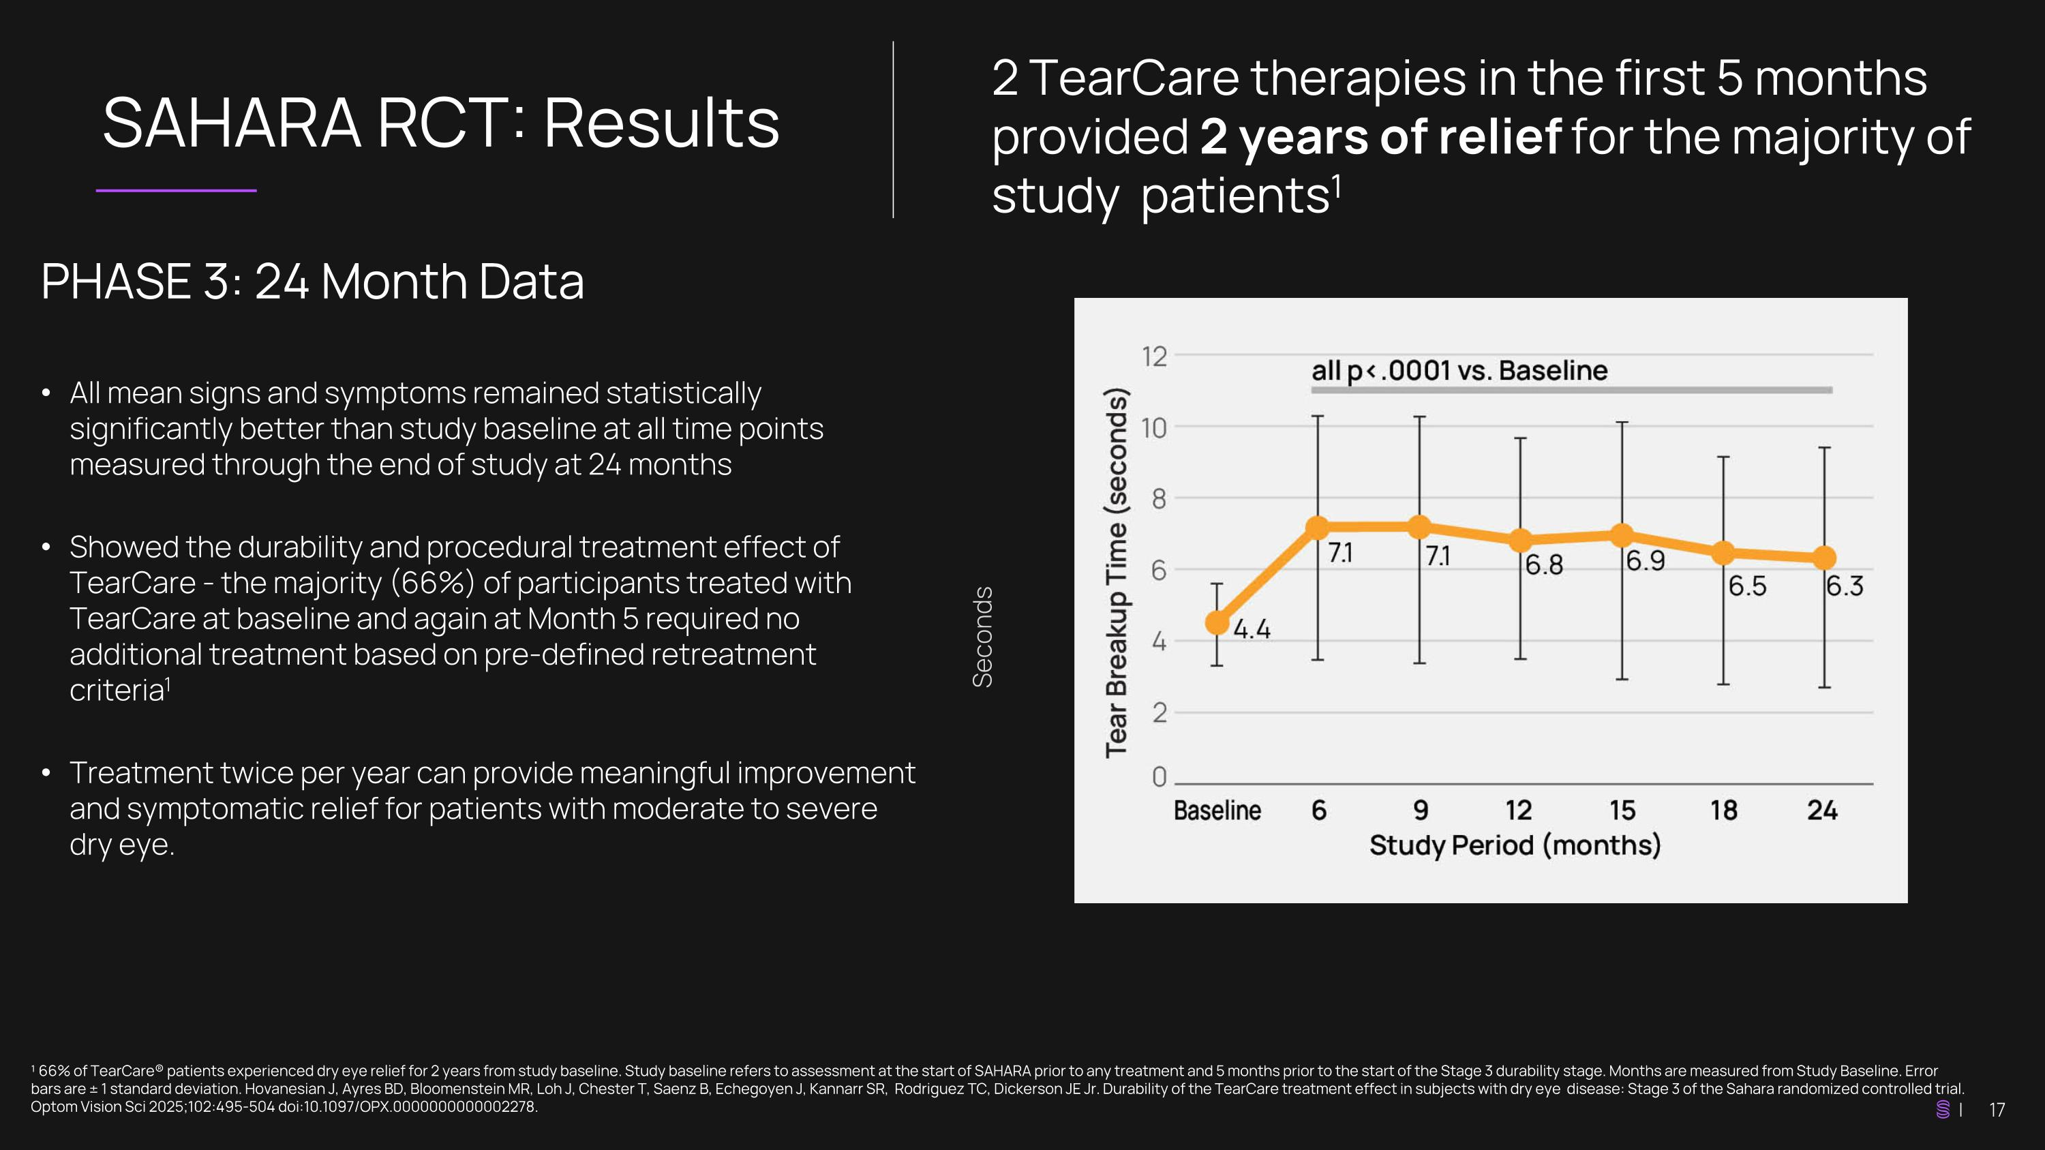
SAHARA RCT: Results ¹ 66% of TearCare® patients experienced dry eye relief for 2 years from study baseline. Study baseline refers to assessment at the start of SAHARA prior to any treatment and 5 months prior to the start of the Stage 3 durability stage. Months are measured from Study Baseline. Error bars are ± 1 standard deviation. Hovanesian J, Ayres BD, Bloomenstein MR, Loh J, Chester T, Saenz B, Echegoyen J, Kannarr SR, Rodriguez TC, Dickerson JE Jr. Durability of the TearCare treatment effect in subjects with dry eye disease: Stage 3 of the Sahara randomized controlled trial. Optom Vision Sci 2025;102:495-504 doi:10.1097/OPX.0000000000002278. 2 TearCare therapies in the first 5 months provided 2 years of relief for the majority of study patients1 PHASE 3: 24 Month Data All mean signs and symptoms remained statistically significantly better than study baseline at all time points measured through the end of study at 24 months Showed the durability and procedural treatment effect of TearCare - the majority (66%) of participants treated with TearCare at baseline and again at Month 5 required no additional treatment based on pre-defined retreatment criteria1 Treatment twice per year can provide meaningful improvement and symptomatic relief for patients with moderate to severe dry eye. Seconds

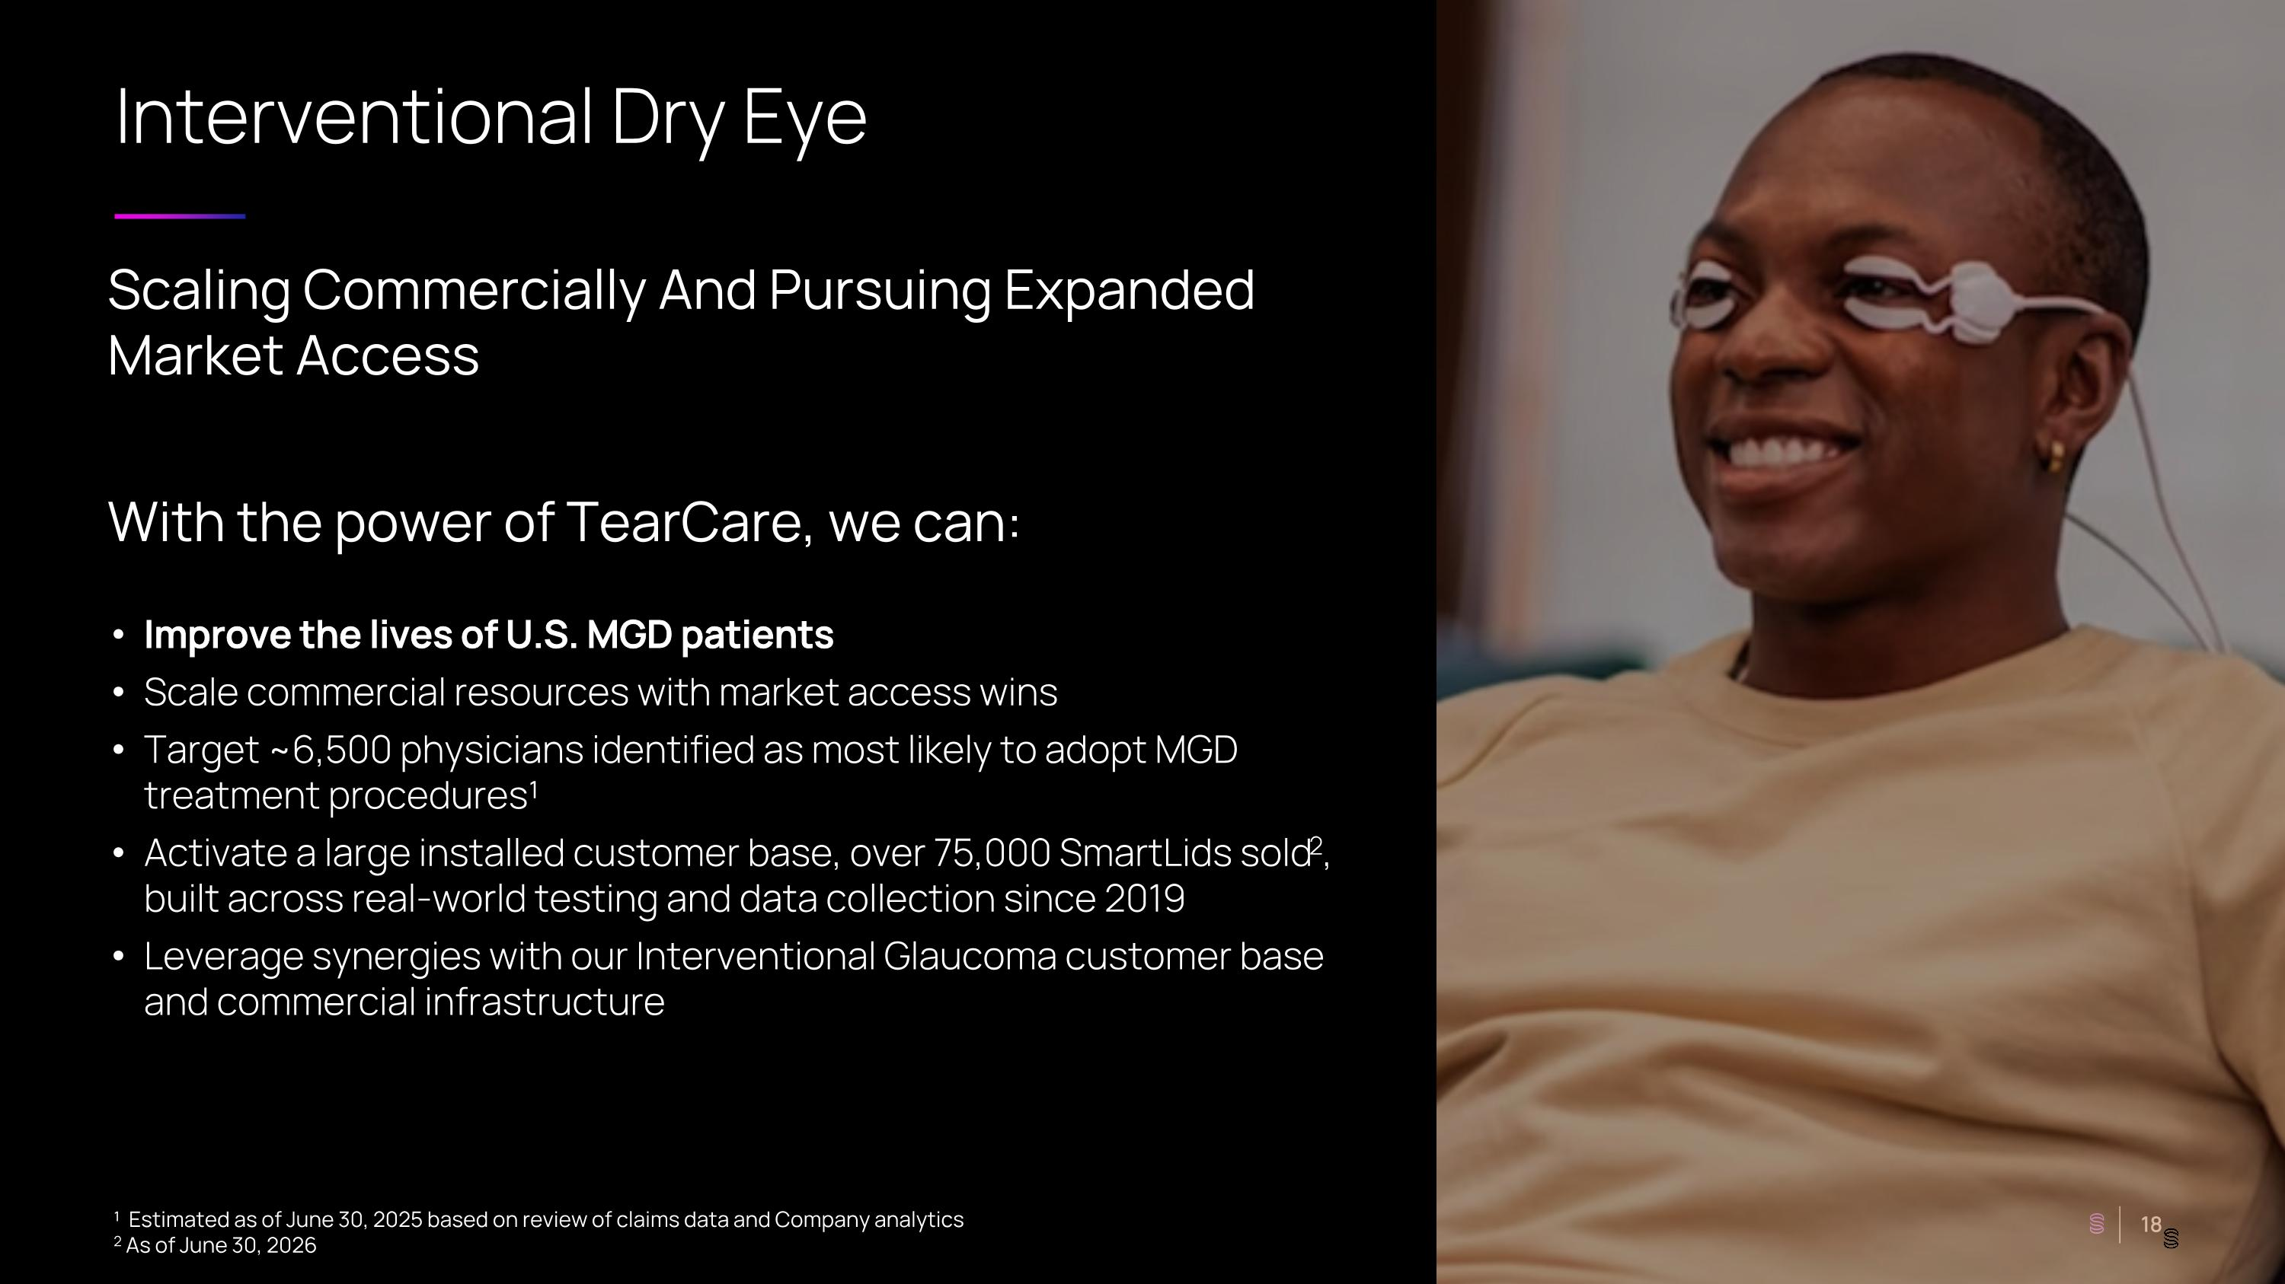
Interventional Dry Eye ¹ Estimated as of June 30, 2025 based on review of claims data and Company analytics 2 As of June 30, 2026 Scaling Commercially And Pursuing Expanded Market Access With the power of TearCare, we can: Improve the lives of U.S. MGD patients Scale commercial resources with market access wins Target ~6,500 physicians identified as most likely to adopt MGD treatment procedures¹ Activate a large installed customer base, over 75,000 SmartLids sold2, built across real-world testing and data collection since 2019 Leverage synergies with our Interventional Glaucoma customer base and commercial infrastructure

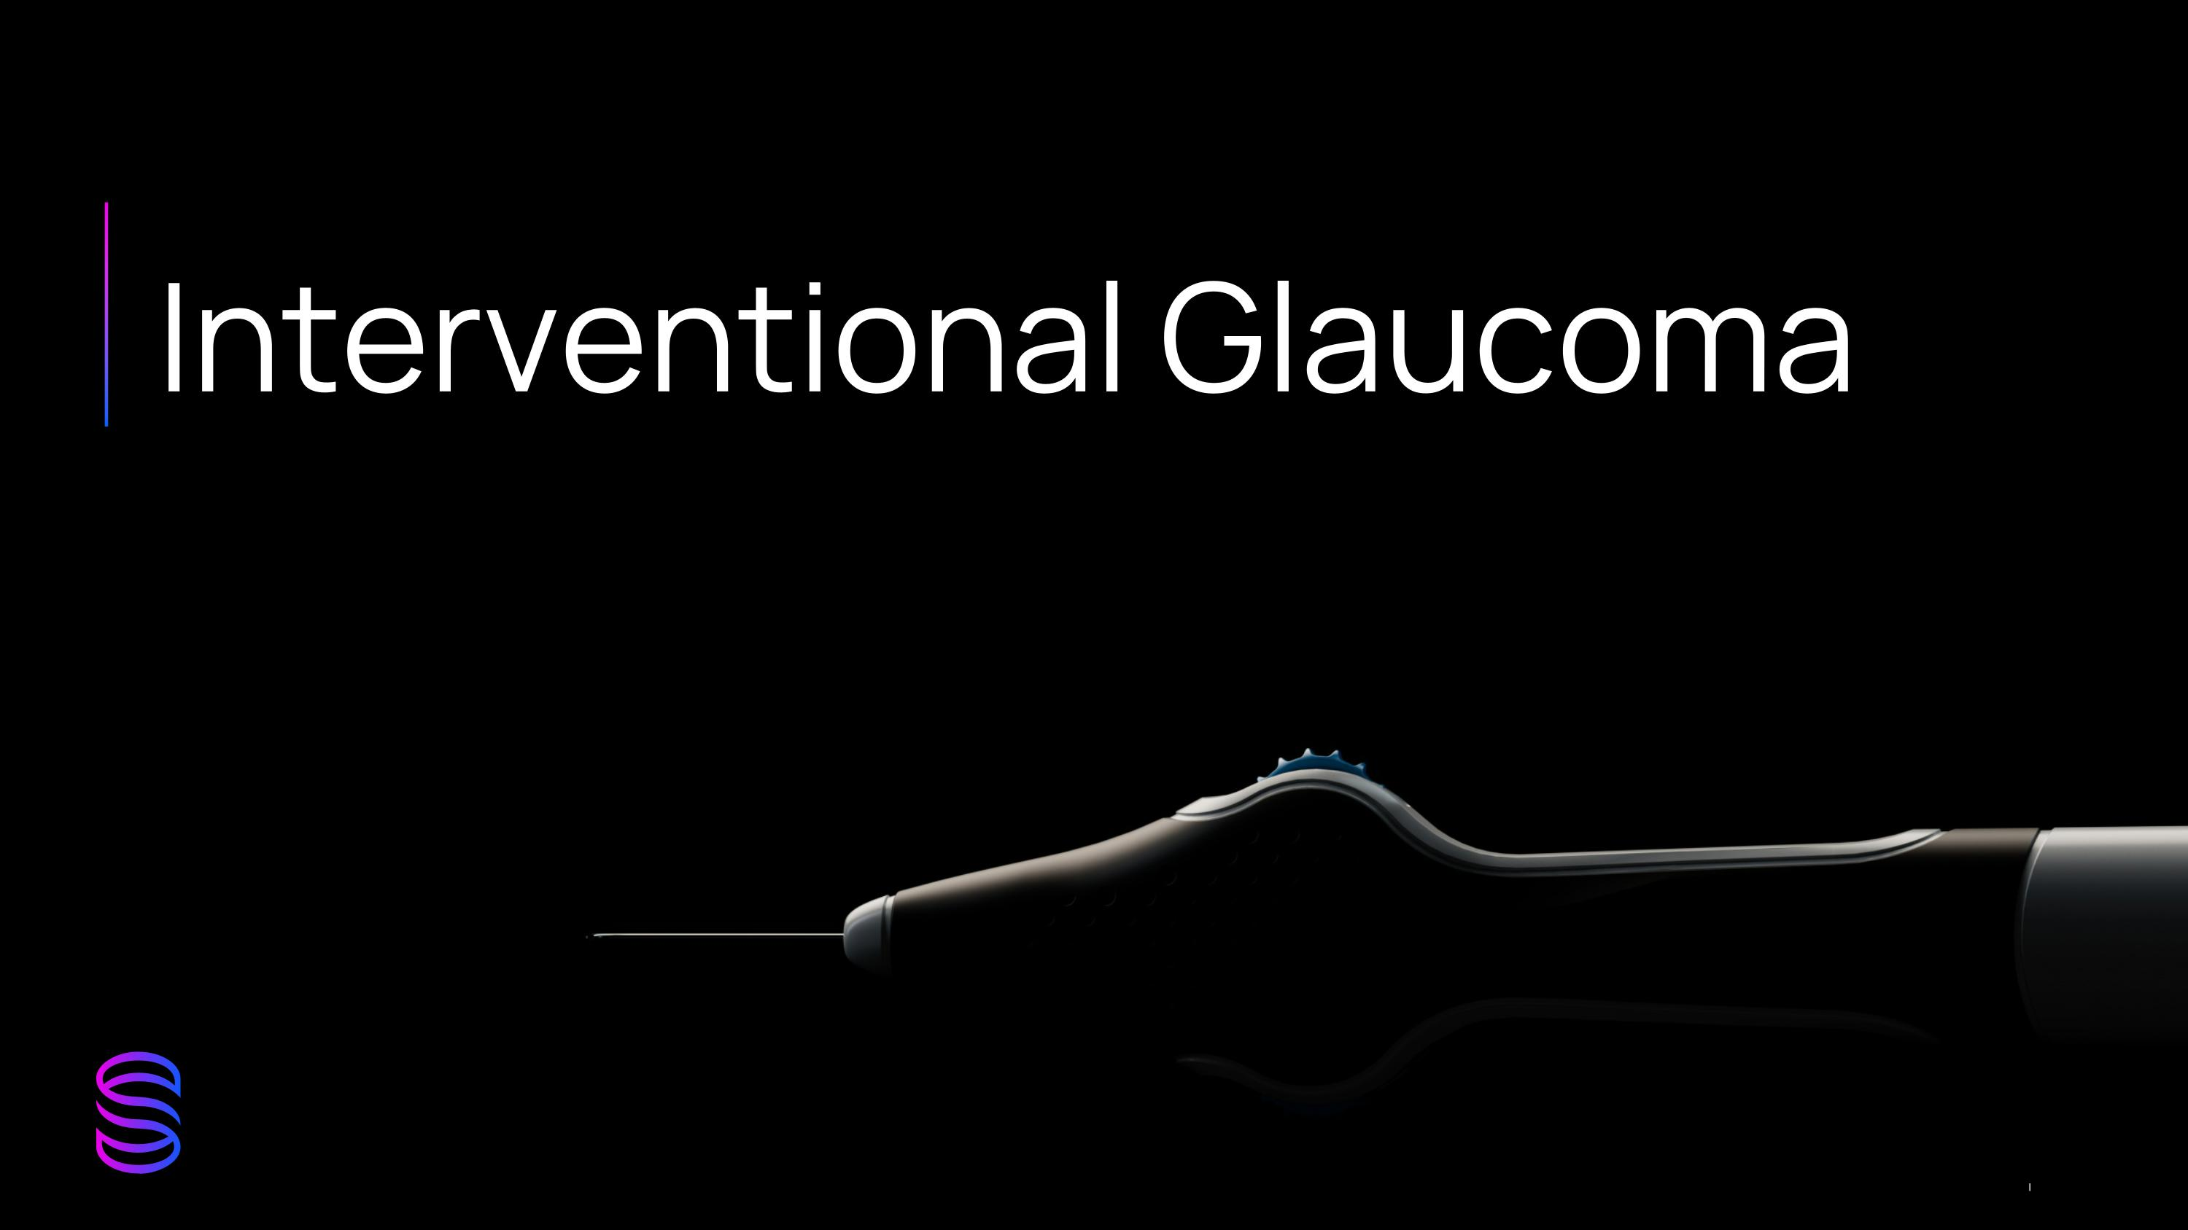
Interventional Glaucoma

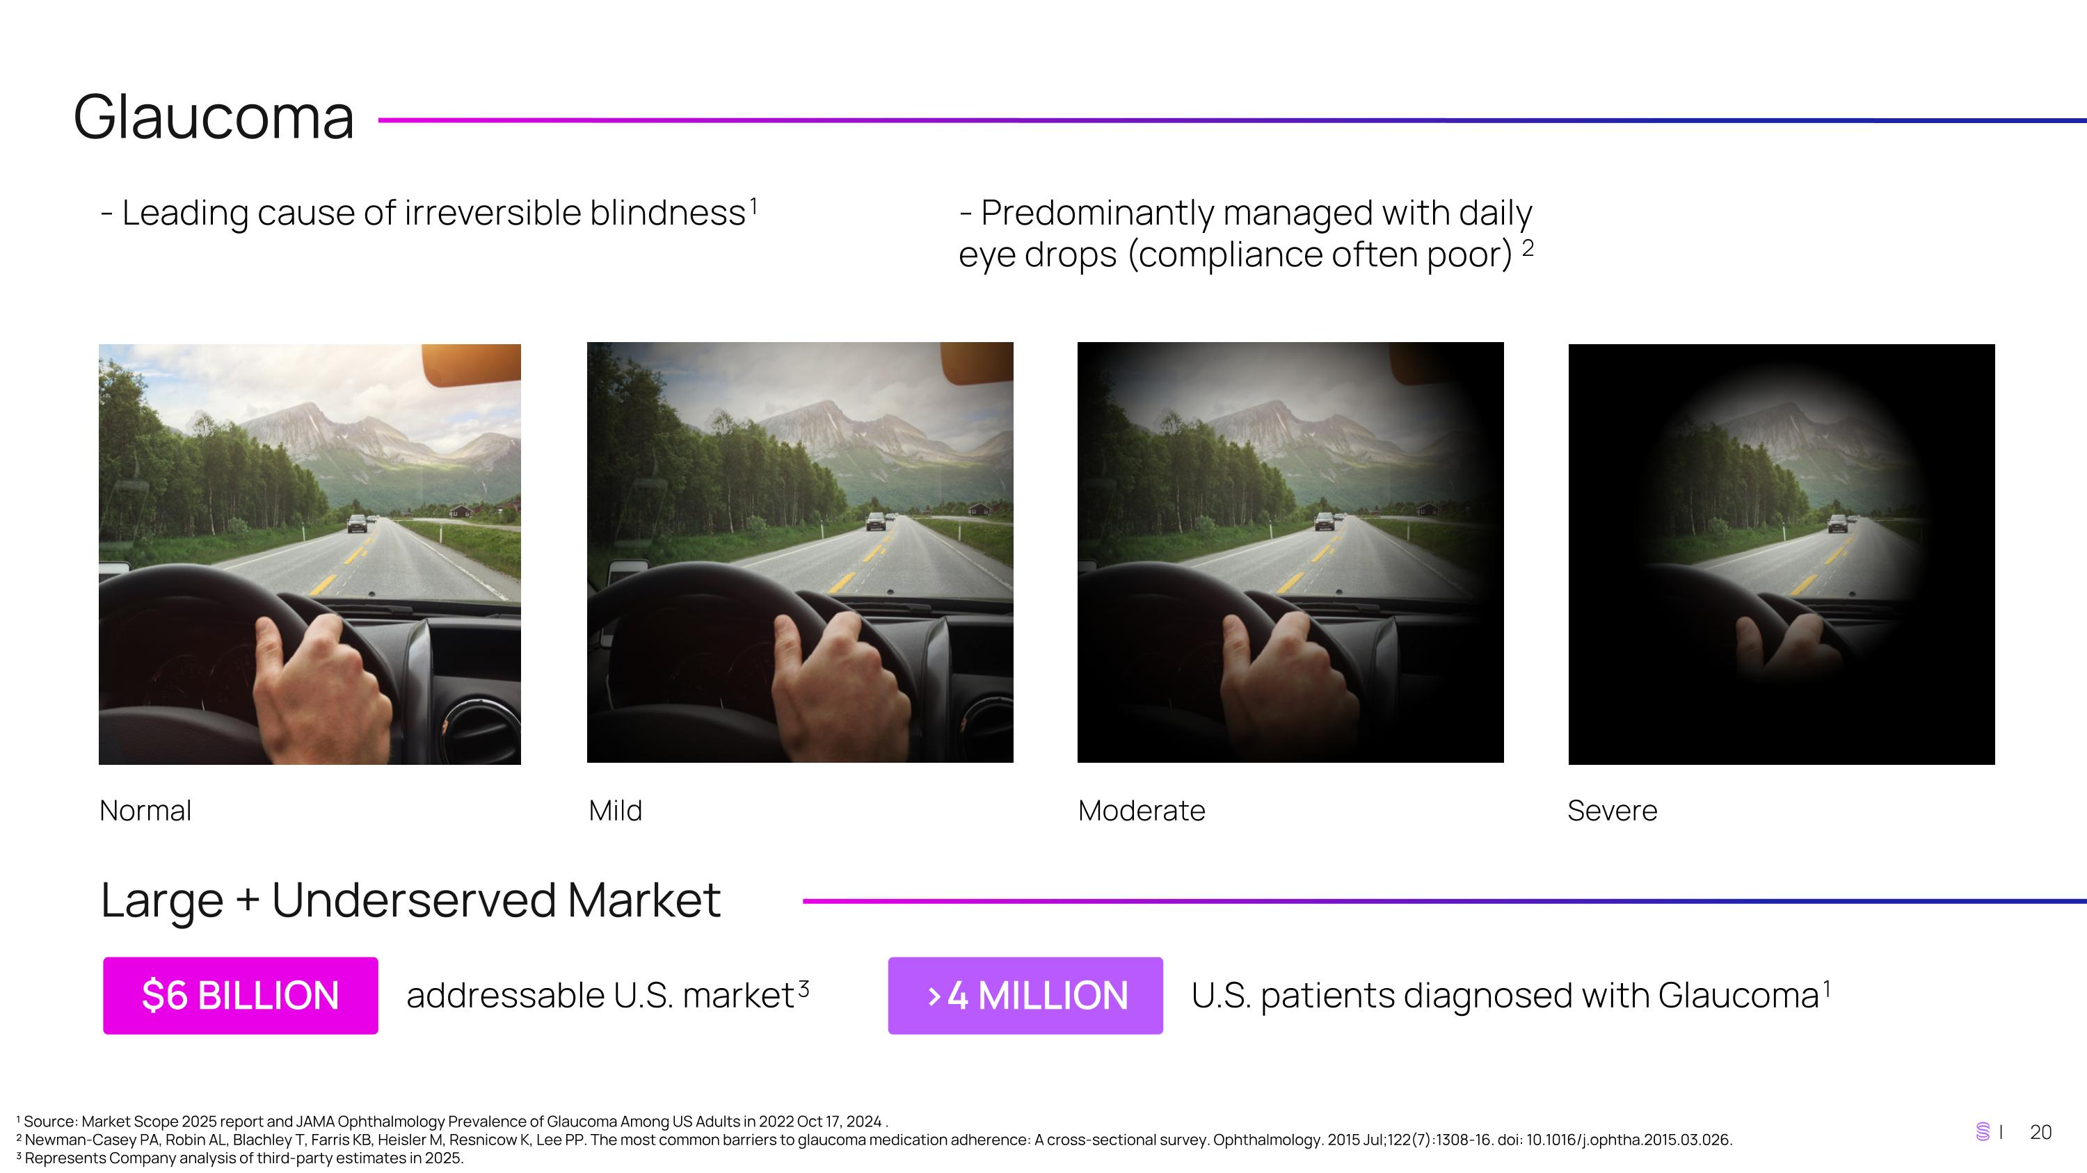
Glaucoma - Leading cause of irreversible blindness1 - Predominantly managed with daily eye drops (compliance often poor)2 Normal Mild Moderate Severe Large + Underserved Market ¹ Source: Market Scope 2025 report and JAMA Ophthalmology Prevalence of Glaucoma Among US Adults in 2022 Oct 17, 2024 . ² Newman-Casey PA, Robin AL, Blachley T, Farris KB, Heisler M, Resnicow K, Lee PP. The most common barriers to glaucoma medication adherence: A cross-sectional survey. Ophthalmology. 2015 Jul;122(7):1308-16. doi: 10.1016/j.ophtha.2015.03.026. ³ Represents Company analysis of third-party estimates in 2025. addressable U.S. market3 U.S. patients diagnosed with Glaucoma1 $6 BILLION >4 MILLION

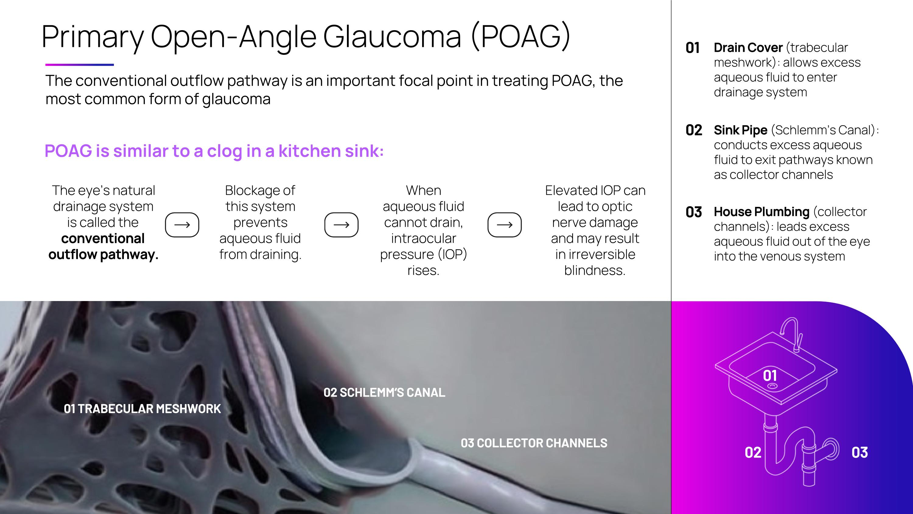
POAG is similar to a clog in a kitchen sink: 01 TRABECULAR MESHWORK 02 SCHLEMM‘S CANAL 03 COLLECTOR CHANNELS 01 02 03 The conventional outflow pathway is an important focal point in treating POAG, the most common form of glaucoma The eye’s natural drainage system is called the conventional outflow pathway. Blockage of this system prevents aqueous fluid from draining. When aqueous fluid cannot drain, intraocular pressure (IOP) rises. Elevated IOP can lead to optic nerve damage and may result in irreversible blindness. Drain Cover (trabecular meshwork): allows excess aqueous fluid to enter drainage system 01 02 Sink Pipe (Schlemm’s Canal): conducts excess aqueous fluid to exit pathways known as collector channels 03 House Plumbing (collector channels): leads excess aqueous fluid out of the eye into the venous system Primary Open-Angle Glaucoma (POAG)

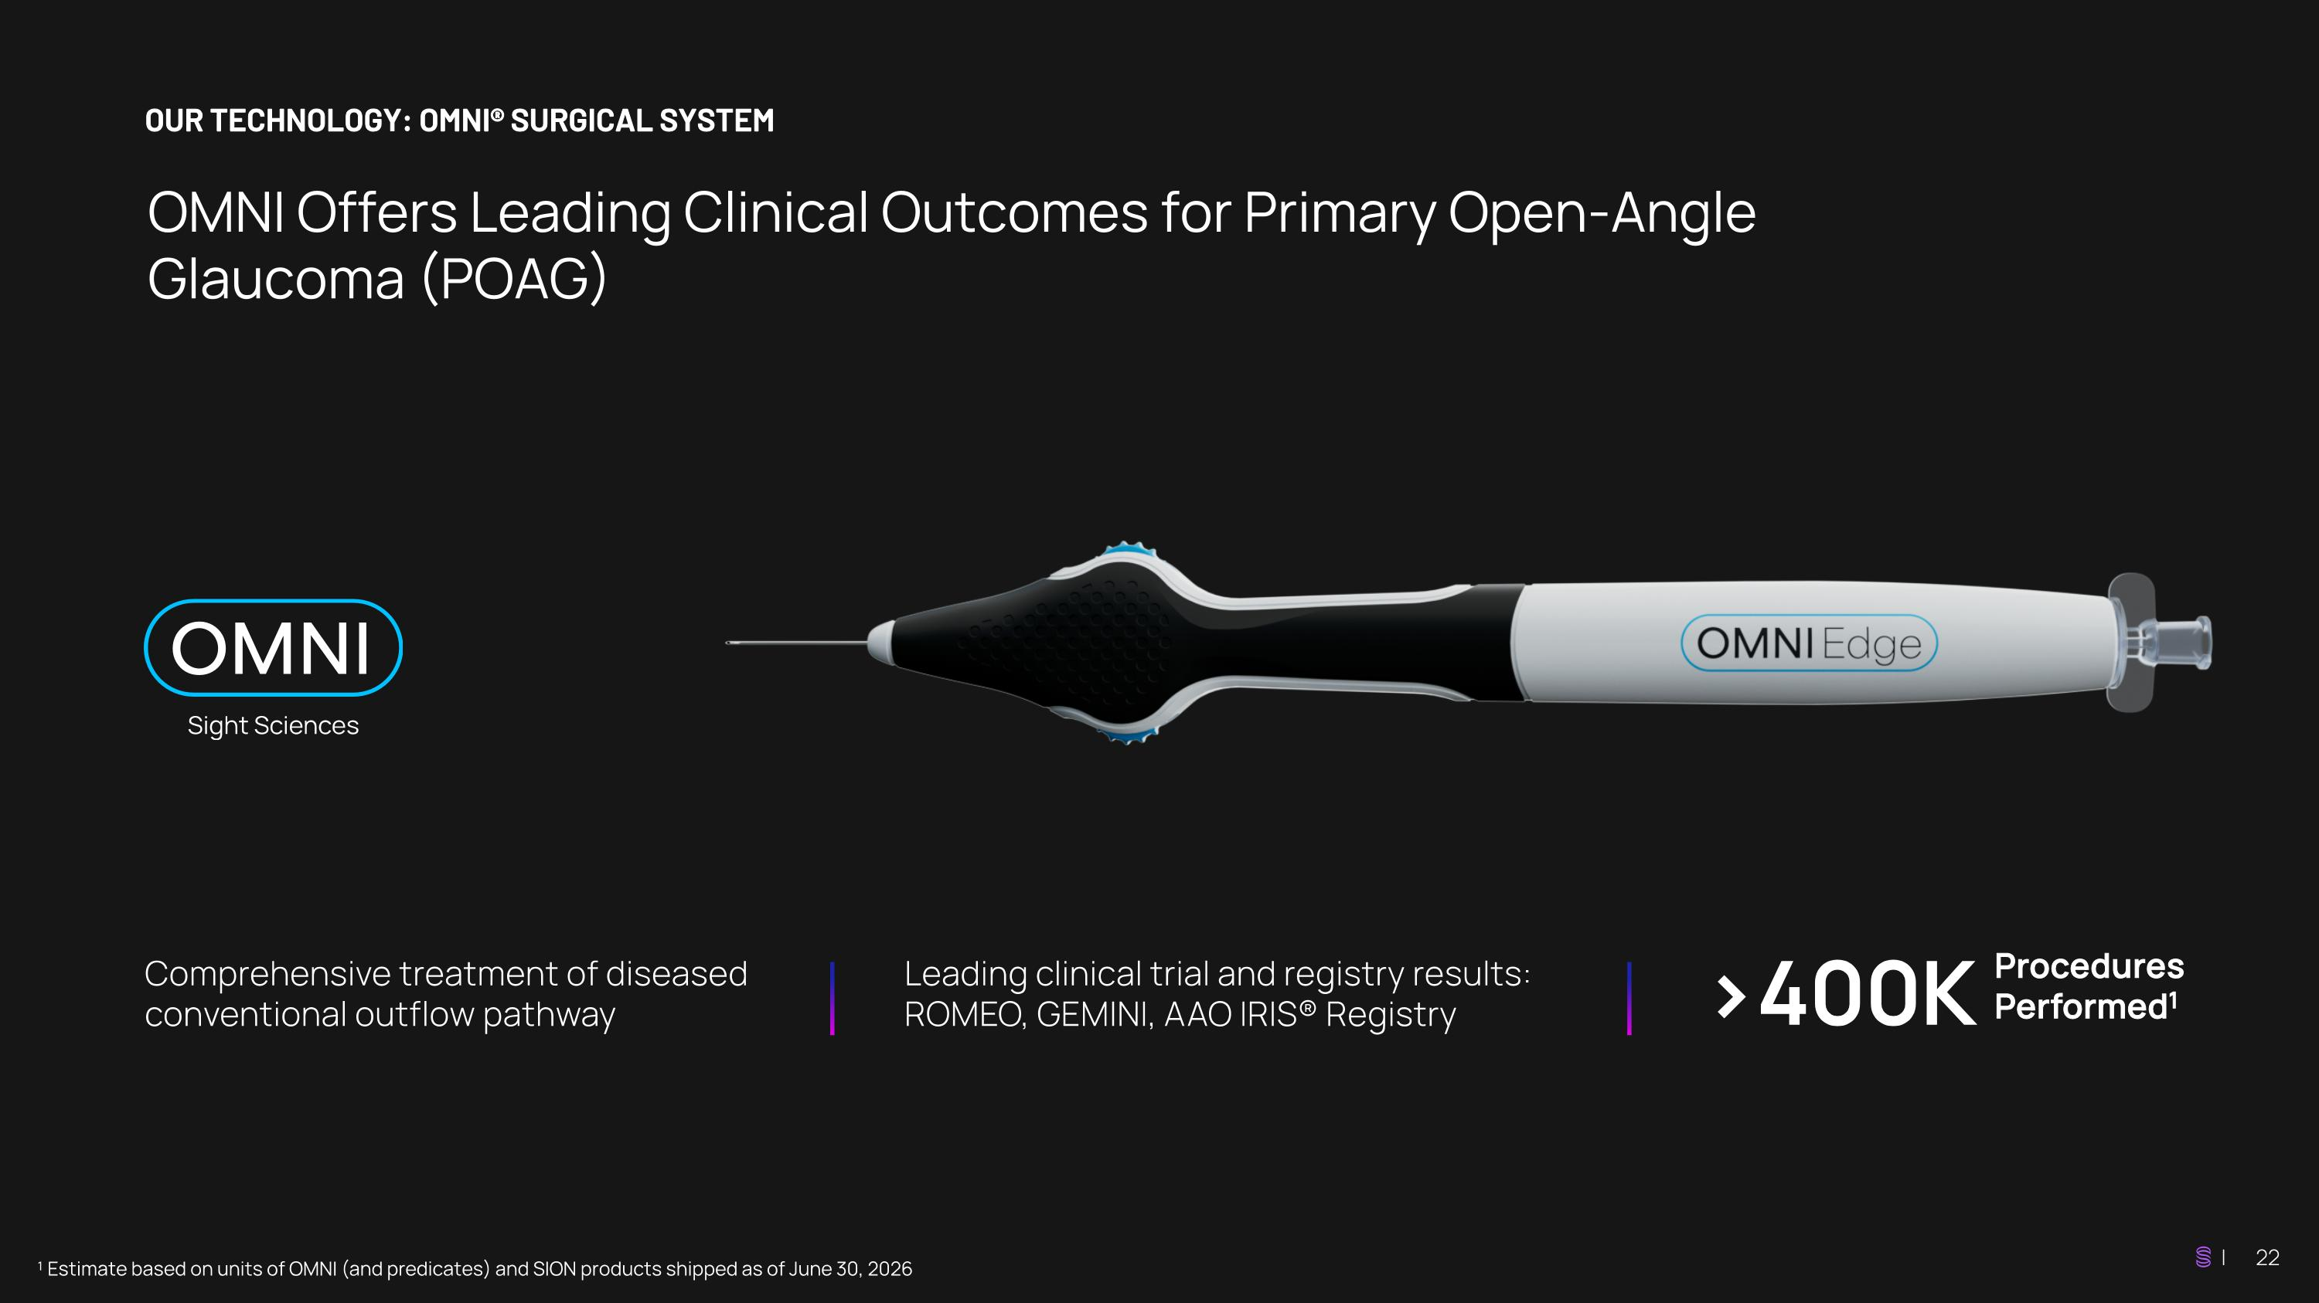
OUR TECHNOLOGY: OMNI® SURGICAL SYSTEM OMNI Offers Leading Clinical Outcomes for Primary Open-Angle Glaucoma (POAG) ¹ Estimate based on units of OMNI (and predicates) and SION products shipped as of June 30, 2026 Comprehensive treatment of diseased conventional outflow pathway Leading clinical trial and registry results: ROMEO, GEMINI, AAO IRIS® Registry >400K Procedures Performed1

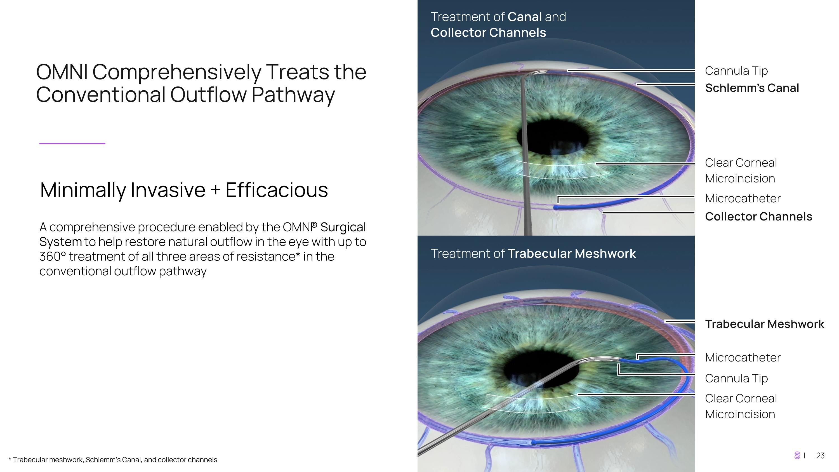
OMNI Comprehensively Treats the Conventional Outflow Pathway Minimally Invasive + Efficacious A comprehensive procedure enabled by the OMNI® Surgical System to help restore natural outflow in the eye with up to 360° treatment of all three areas of resistance* in the conventional outflow pathway * Trabecular meshwork, Schlemm’s Canal, and collector channels

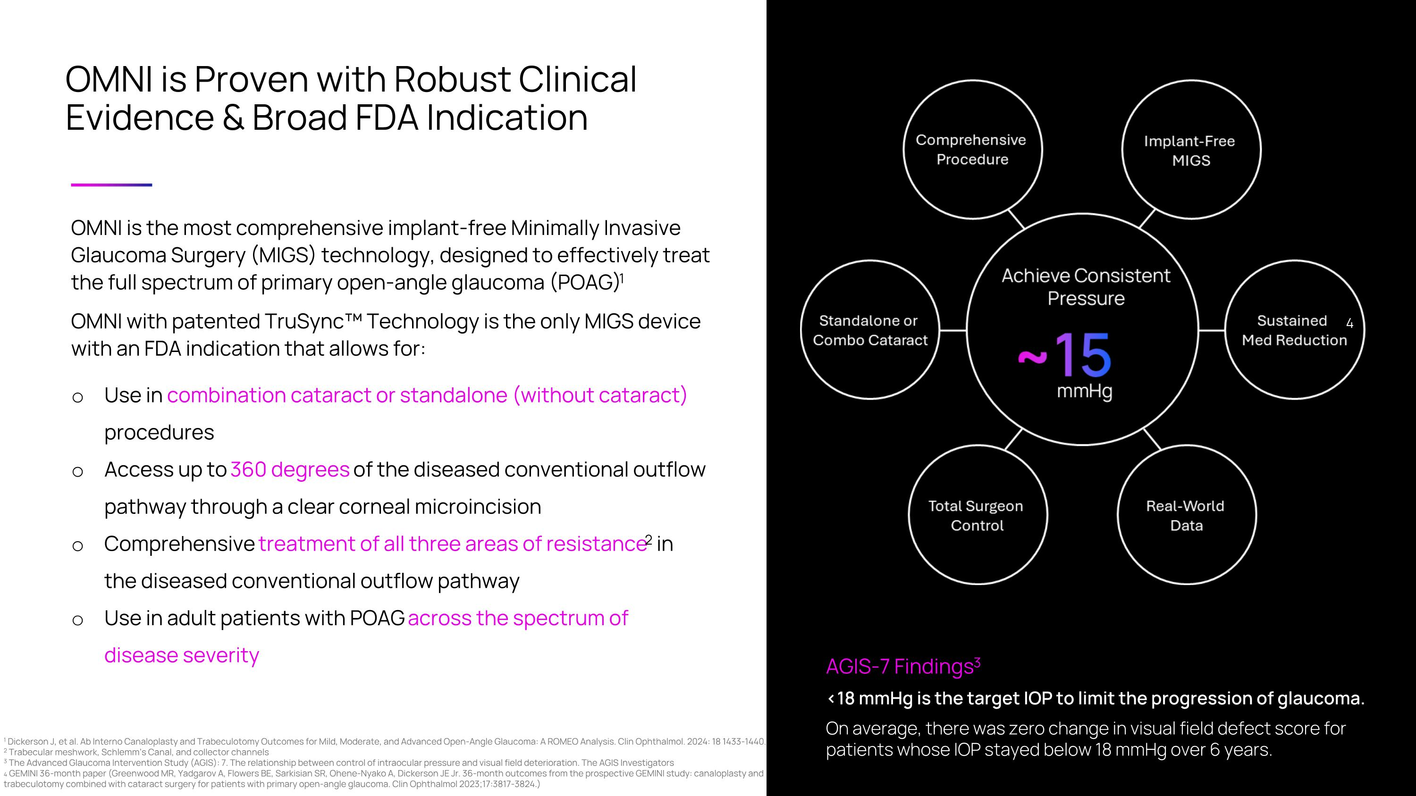
OMNI is Proven with Robust Clinical Evidence & Broad FDA Indication AGIS-7 Findings3 <18 mmHg is the target IOP to limit the progression of glaucoma. On average, there was zero change in visual field defect score for patients whose IOP stayed below 18 mmHg over 6 years. OMNI is the most comprehensive implant-free Minimally Invasive Glaucoma Surgery (MIGS) technology, designed to effectively treat the full spectrum of primary open-angle glaucoma (POAG)1 OMNI with patented TruSync Technology is the only MIGS device with an FDA indication that allows for: Use in combination cataract or standalone (without cataract) procedures Access up to 360 degrees of the diseased conventional outflow pathway through a clear corneal microincision Comprehensive treatment of all three areas of resistance2 in the diseased conventional outflow pathway Use in adult patients with POAG across the spectrum of ?disease severity 1 Dickerson J, et al. Ab Interno Canaloplasty and Trabeculotomy Outcomes for Mild, Moderate, and Advanced Open-Angle Glaucoma: A ROMEO Analysis. Clin Ophthalmol. 2024: 18 1433-1440. ?2 Trabecular meshwork, Schlemm’s Canal, and collector channels 3 The Advanced Glaucoma Intervention Study (AGIS): 7. The relationship between control of intraocular pressure and visual field deterioration. The AGIS Investigators 4 GEMINI 36-month paper (Greenwood MR, Yadgarov A, Flowers BE, Sarkisian SR, Ohene-Nyako A, Dickerson JE Jr. 36-month outcomes from the prospective GEMINI study: canaloplasty and trabeculotomy combined with cataract surgery for patients with primary open-angle glaucoma. Clin Ophthalmol 2023;17:3817-3824.) 4

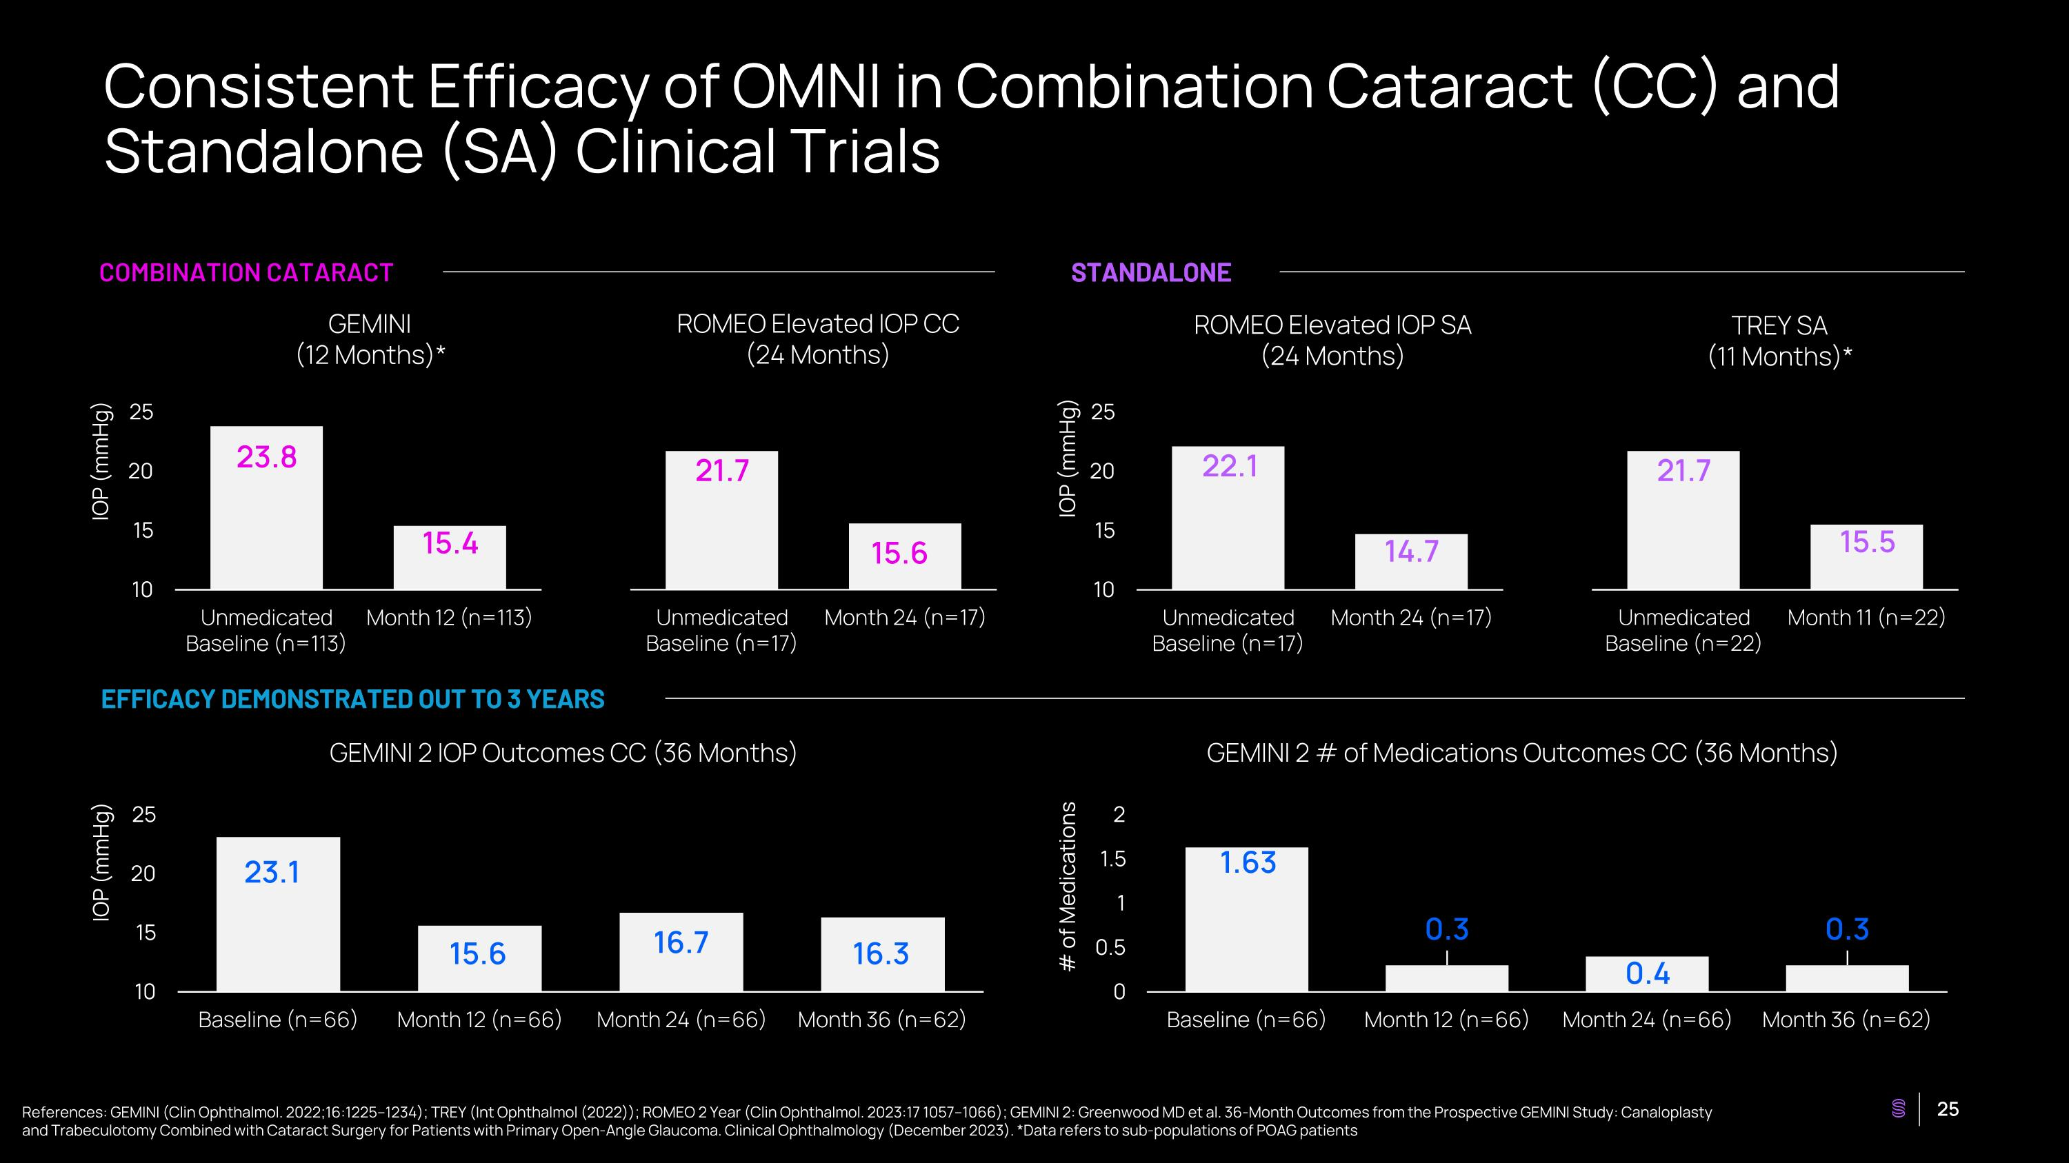
Consistent Efficacy of OMNI in Combination Cataract (CC) and Standalone (SA) Clinical Trials COMBINATION CATARACT STANDALONE EFFICACY DEMONSTRATED OUT TO 3 YEARS GEMINI (12 Months)* ROMEO Elevated IOP CC (24 Months) ROMEO Elevated IOP SA (24 Months) TREY SA (11 Months)* GEMINI 2 IOP Outcomes CC (36 Months) GEMINI 2 # of Medications Outcomes CC (36 Months) IOP (mmHg) IOP (mmHg) IOP (mmHg) # of Medications References: GEMINI (Clin Ophthalmol. 2022;16:1225–1234); TREY (Int Ophthalmol (2022)); ROMEO 2 Year (Clin Ophthalmol. 2023:17 1057–1066); GEMINI 2: Greenwood MD et al. 36-Month Outcomes from the Prospective GEMINI Study: Canaloplasty and Trabeculotomy Combined with Cataract Surgery for Patients with Primary Open-Angle Glaucoma. Clinical Ophthalmology (December 2023). *Data refers to sub-populations of POAG patients

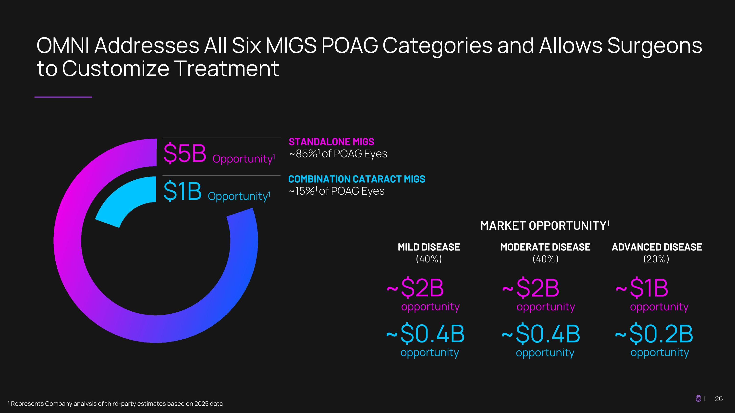
OMNI Addresses All Six MIGS POAG Categories and Allows Surgeons to Customize Treatment ¹ Represents Company analysis of third-party estimates based on 2025 data MILD DISEASE (40%) MODERATE DISEASE (40%) ADVANCED DISEASE (20%) ~$2B opportunity ~$2B opportunity ~$1B opportunity ~$0.4B opportunity ~$0.4B opportunity ~$0.2B opportunity $5B Opportunity1 $1B Opportunity1 STANDALONE MIGS ~85%1 of POAG Eyes COMBINATION CATARACT MIGS ~15%1 of POAG Eyes MARKET OPPORTUNITY1

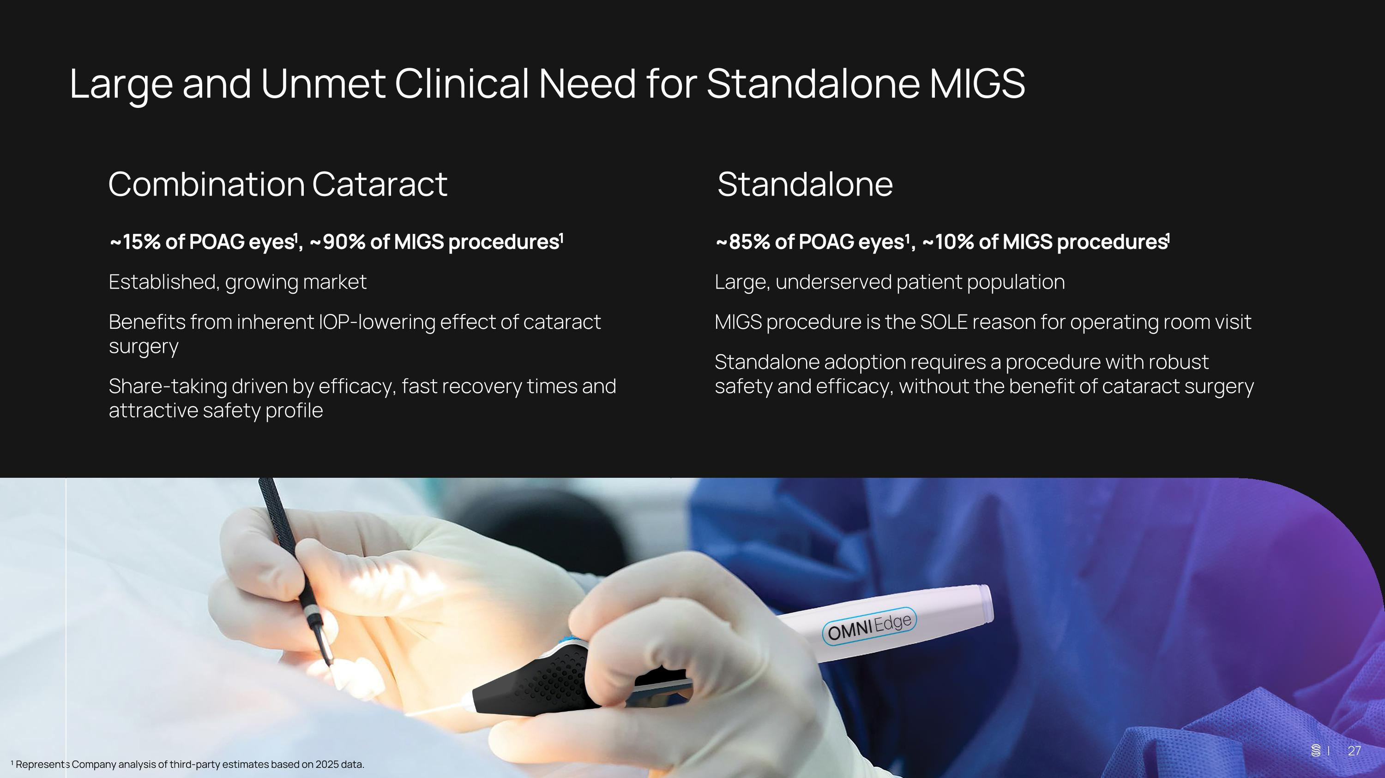
Large and Unmet Clinical Need for Standalone MIGS Combination Cataract Standalone | 27 ~15% of POAG eyes1, ~90% of MIGS procedures1 Established, growing market Benefits from inherent IOP-lowering effect of cataract surgery Share-taking driven by efficacy, fast recovery times and attractive safety profile ~85% of POAG eyes¹, ~10% of MIGS procedures1 Large, underserved patient population MIGS procedure is the SOLE reason for operating room visit Standalone adoption requires a procedure with robust safety and efficacy, without the benefit of cataract surgery ¹ Represents Company analysis of third-party estimates based on 2025 data.

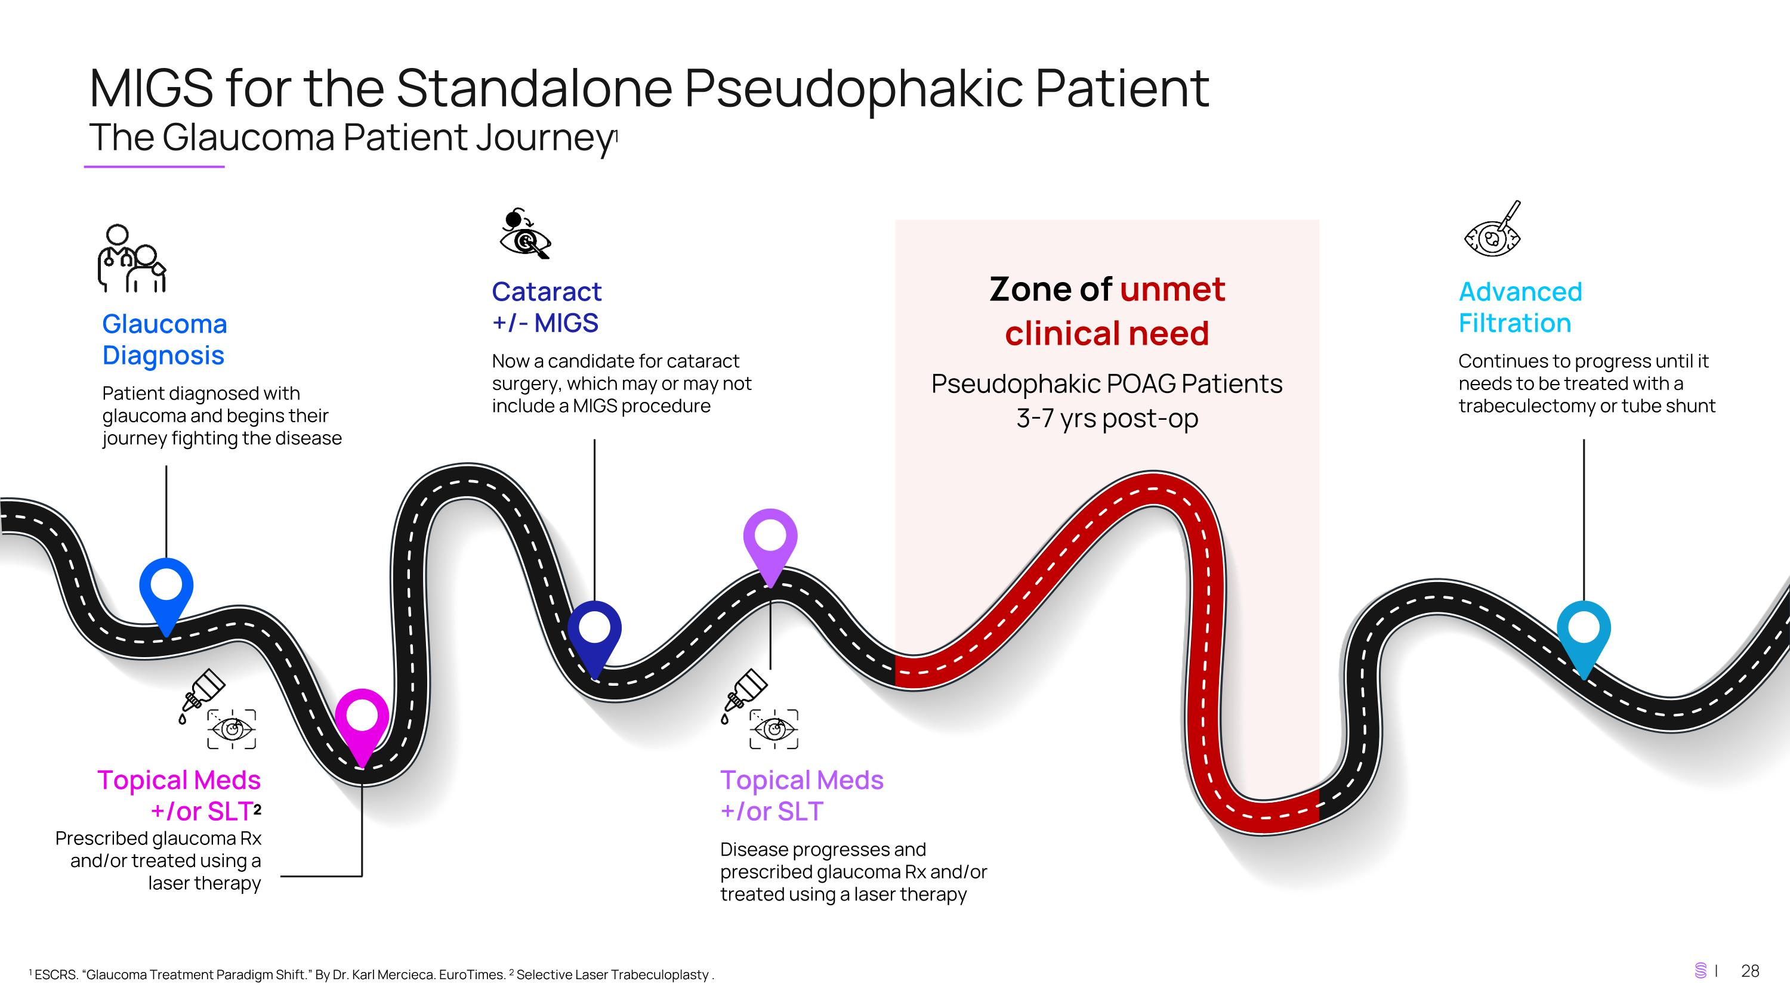
MIGS for the Standalone Pseudophakic Patient ?The Glaucoma Patient Journey1 1 ESCRS. “Glaucoma Treatment Paradigm Shift.” By Dr. Karl Mercieca. EuroTimes. 2 Selective Laser Trabeculoplasty . Zone of unmet ?clinical need Pseudophakic POAG Patients ?3-7 yrs post-op Glaucoma Diagnosis Patient diagnosed with glaucoma and begins their journey fighting the disease Topical Meds +/or SLT2 Prescribed glaucoma Rx and/or treated using a laser therapy Cataract?+/- MIGS Now a candidate for cataract surgery, which may or may not include a MIGS procedure Topical Meds ?+/or SLT Disease progresses and prescribed glaucoma Rx and/or treated using a laser therapy Advanced ?Filtration Continues to progress until it needs to be treated with a trabeculectomy or tube shunt

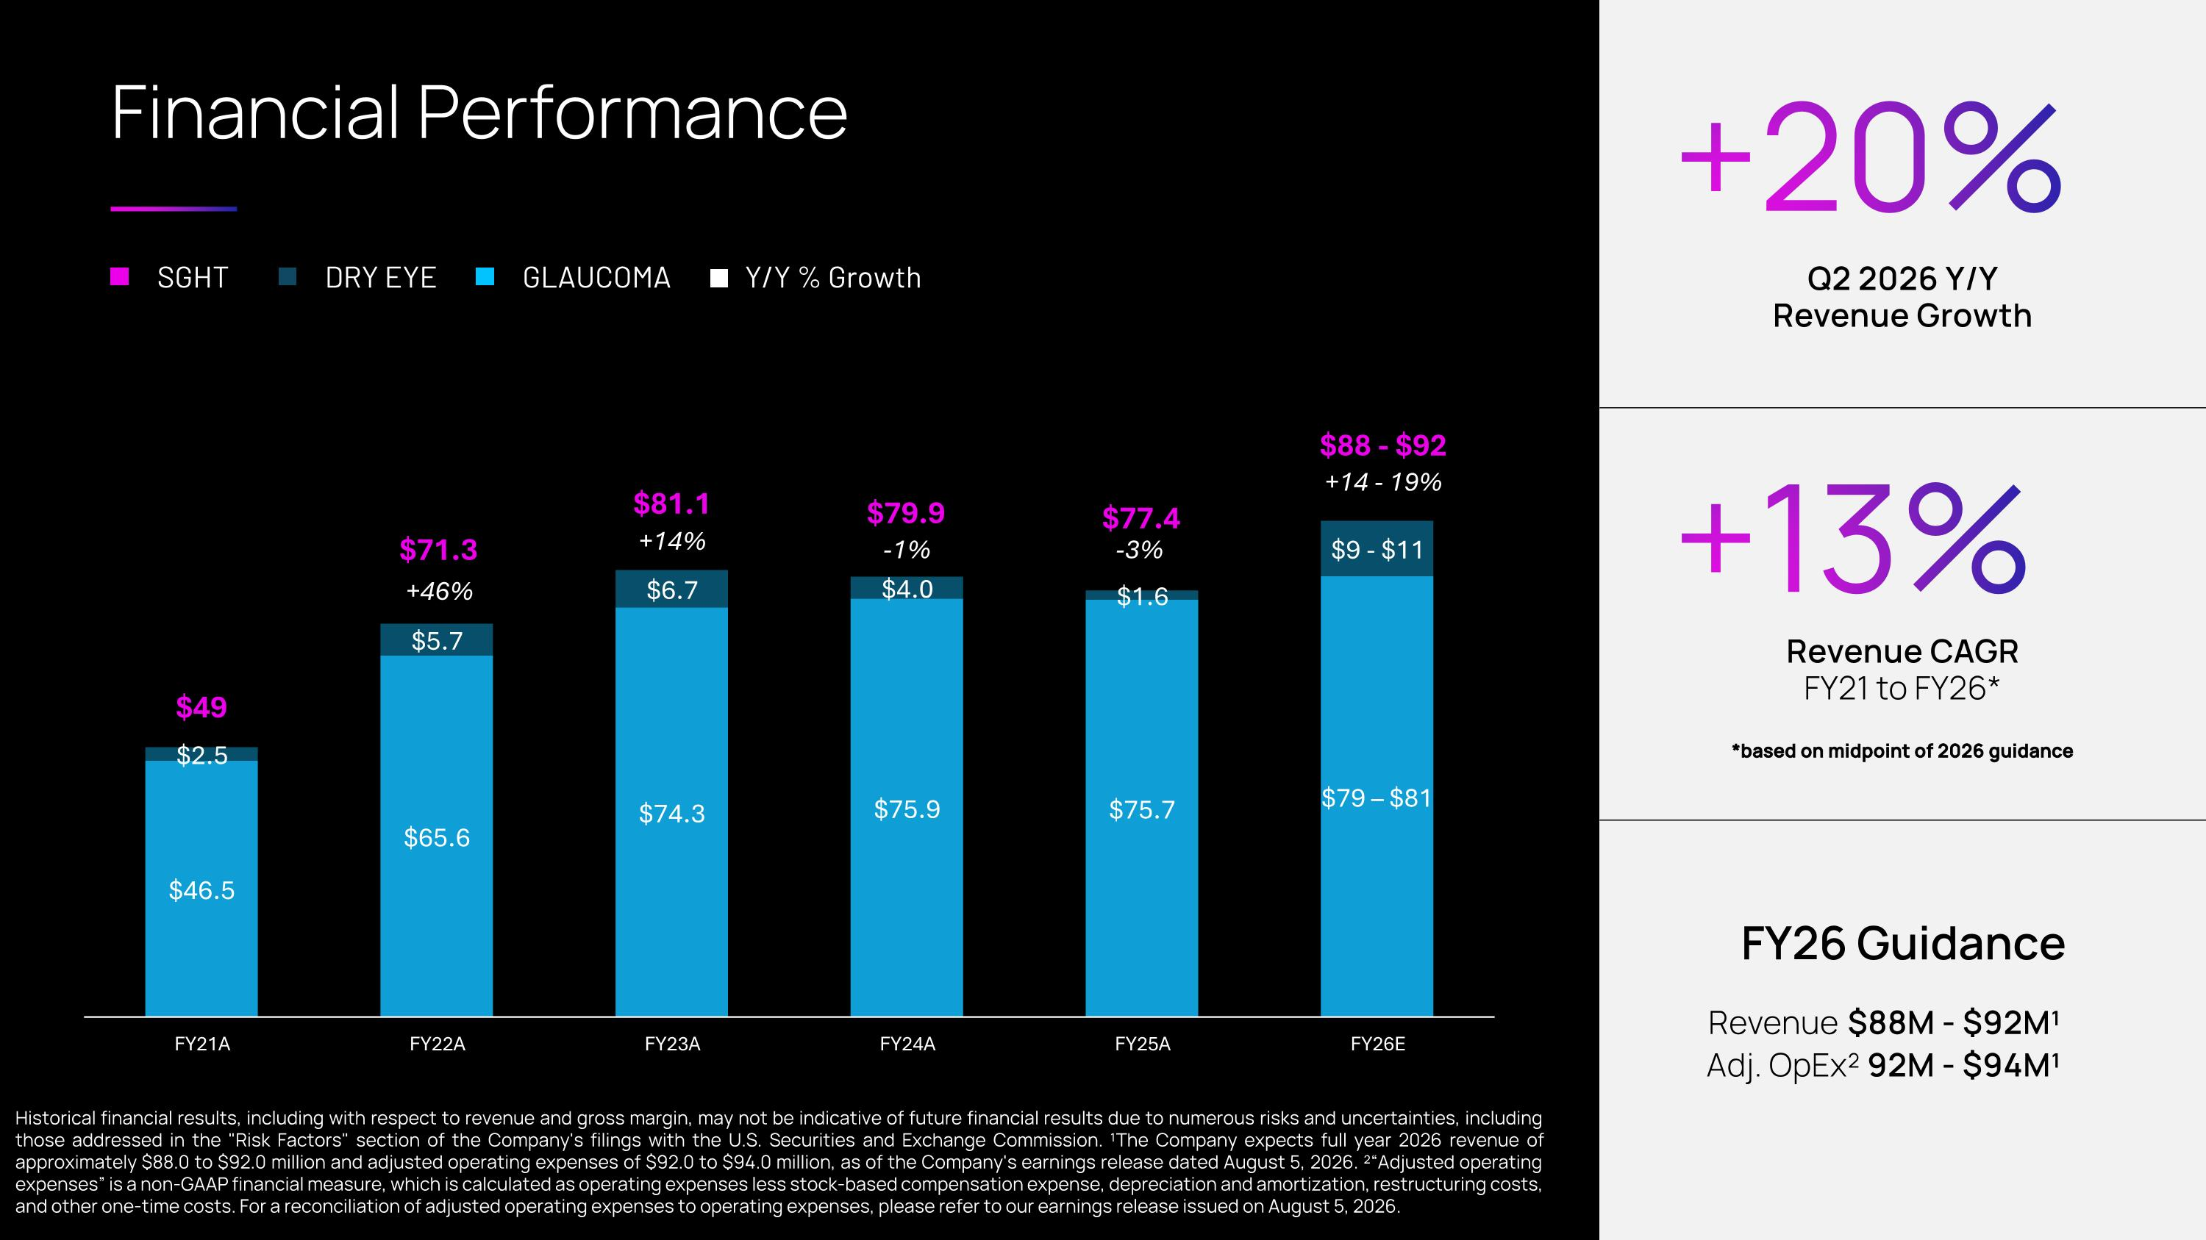
Financial Performance SGHT DRY EYE GLAUCOMA Y/Y % Growth +20% Q2 2026 Y/Y Revenue Growth FY26 Guidance Revenue $88M - $92M¹ Adj. OpEx² 92M - $94M¹ Historical financial results, including with respect to revenue and gross margin, may not be indicative of future financial results due to numerous risks and uncertainties, including those addressed in the "Risk Factors" section of the Company's filings with the U.S. Securities and Exchange Commission. ¹The Company expects full year 2026 revenue of approximately $88.0 to $92.0 million and adjusted operating expenses of $92.0 to $94.0 million, as of the Company's earnings release dated August 5, 2026. ²“Adjusted operating expenses” is a non-GAAP financial measure, which is calculated as operating expenses less stock-based compensation expense, depreciation and amortization, restructuring costs, and other one-time costs. For a reconciliation of adjusted operating expenses to operating expenses, please refer to our earnings release issued on August 5, 2026. $49 $71.3 $81.1 $79.9 $77.4 $88 - $92 +13% Revenue CAGR FY21 to FY26* *based on midpoint of 2026 guidance +46% +14% -1% -3% +14 - 19%


Keep Seeing TM

